OCR Computer Science Project

Name: Aman Messinezis
Candidate Number: 3706
School: Whitmore High School
Title of Project: Microbit Physical Game

Contents
Analysis 3
Design 13
Development 24

Analysis:
DEFINING THE PROBLEM AND STAKEHOLDERS
Problem Identification:
Currently, young children tend to find playing on their games console with their friends more entertaining than actually playing outside. There aren’t many applications of fusing the two together. On average, children play 21 hours of video games per week, and can cause mental and physical illnesses. Having the ability to create an application that can do so would improve the health and fitness for these young children, as it could be a compromise between having a new way of entertainment through the use of going outside and having fun with friends.
Outlining the problem
The Microbit Physical Game Investigation will be a development of a game that uses the Microbit to enable a Capture the Flag game to be played around the school site or elsewhere. Capture the Flag is an outdoor activity game that consists of two teams. The aim of the game is to capture the enemy flag and take it to your base without getting caught. If you do get caught, you will be placed in a jail where you may only get freed by other allies who have not been caught by the enemy team. There will be a set number of flags defined by the user. New flags will be displayed when the flag that has been currently captured is placed in base.
Target Audience
My project will be tailored to fit a stereotypical 11-13-year-old. I’ve chosen this audience as it is a good way for Year 7s to make new friends. Furthermore, as a certain level of maturity is needed to play the game as a lot of movement is required, I believe that Year 7s and 8s would be suited to play the game.
Controls for the solution
Controls for the solution include cool down timer buttons A and B. The cool down timer will last for 3 seconds by default but can be altered on the start-up screen on a computer. This would be a good solution for those of younger age as it’s easier for them to play the game with so limited buttons. Having a cooldown timer will make the game much more fun and fairer to play rather than mashing the button to capture/take back and place flags back to base. For an “attacker”, button A enables users to take the flag from the opposing base and can free players from jail one at a time. Button B places the flag in team base. For a “defending” player, button A is used to put attackers in jail, and simultaneously take flags back from the opposing attackers. Button B again, places the flag back in the team base.
JUSTIFICATION OF HOW TO SOLVE THE PROBLEM CAN BE SOLVED BY COMPUTATION METHODS
Thinking Abstractly

Abstraction would be a necessary computational method as there is a lot of detail that isn't required to focus on. Therefore, relevant detail including knowing the location of the player, the distance between them and the opposing flag would be more important than thinking of artwork made on the microbit such as the flag which can be represented as a dot.
Main features of abstraction used in my project will include:
- The display of the microbit. Although there will be a startup screen displayed on a PC display before the game starts, the microbit only has a 5x5 display screen. Having such a large complex game would require a lot of heads up display for the player, including a mini map for where the flag and the score of the game. Therefore, simple symbols would need to be used to wrap around this problem and for that reason, abstraction is required.
- The flags on either base. My game requires Bluetooth beacons to be set up as a way to place the flag. However, there will not be a visual flag in sight, but will be displayed on the microbit screen once collected. As this is different to real life capture the flag, I’d also be using abstraction here too.

Thinking Ahead

Recognizing what inputs, outputs and preconditions are required. For example, inputs in the "location" subroutine would include the integer (x,y) coordinates, set to 0 and the output will change every time there is a change in distance.
- The need for reusable program components and libraries can save time in completing the project as these components would've already been written, debugged and thoroughly tested.
- Specifying preconditions, inputs and outputs as part of the documentation of a subroutine ensures that the user knows what checks, if any, must be carried out before calling the subroutine.

Problem Decomposition

As this project contains a bulk of problems, breaking them down into smaller problems using a Top-down design could make it more manageable to solve and is a great way to recognise the order of events. Furthermore, if each module is self-contained and well documented with inputs, outputs and preconditions specified, it should be relatively easy to find the modules which need to be changed, knowing that this will not affect the rest of the program.

Thinking Logically

To assign who has the flag on either team and would have to constantly be cycled over to make sure it is updated when there is someone else who has the flag.
Players must be a certain distance away from their base depending on the settings and a while loop would be set to True if the defending players enter the area.
A while loop would also be implemented to a cooldown timer which is only true when the button is pressed and it is not close enough to their desired target.
It requires a precise location and should be updated the instance when there is a change in location.

Sequential, selective and iterative steps must be taken simultaneously without the need of human error and there is no alternative solution other than a computer that can complete these several tasks.

Research
Uncharted 4 includes a multiplayer game mode called Plunder, which has a few of the features in a regular CTF game mode. The objective is to carry the idol spawned in the centre of the map and take it to your team base without the other team taking it from you. For an augmented game, the environmental features of Uncharted 4 will not be mentioned.
What I would take from this game mode would be the essential heads up display features, such as knowing whether the idol has been dropped, respawned or placed in the enemy/ally treasure chest, the scoreboard throughout the game, and the weaponry display set including the gun, ammo and grenade availability. For the attackers, it would be just be where the flag is. The idol is displayed as a small symbol in Uncharted 4 that moves around the map which isn’t so detailed. I would take this idea but would have to strip away a lot of information such as the building outlines, as my source code won’t be able to figure out its surroundings, especially on the microbit. I’d further have to remove practically everything in the heads-up display as it doesn’t fit the stereotypical essentials in a CTF game. However, the flag would be a key feature for an attackers microbit. And depending on the options, an arrow will point to the flag, and will be looped to ensure that it is in real time.
The mini map also displays enemy players in red and allies in blue. This is a great advantage as players can strategically think where they should go to find a way to place the idol in the treasure chest. I would be able to integrate this idea onto the microbit, yet because of the resolution, there would have to be major tweaks which will clearly be differentiated to a more complex mini map that Naughty Dog’s Uncharted 4 has to offer. Dots wouldn’t be used to represent enemies and allies as it’d be a much more interesting game without the need of knowing based around a microbit. Surroundings is a key strategic play of this game.
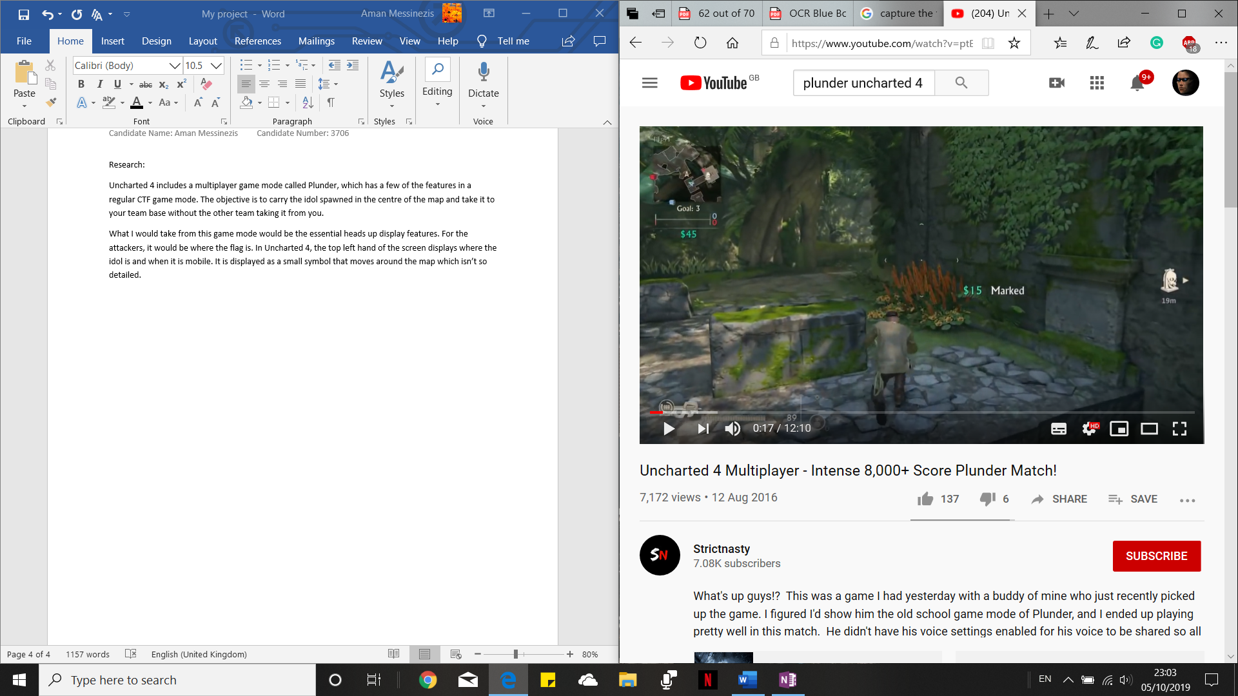
Uncharted 4 Multiplayer Mini Map on the game mode “Plunder”

The game continues to display all sorts of action-packed works, including weaponry to take down enemies. This way, the game is much more intense and allows players to think wise on where their next steps will be. I will not be implementing this in my project as for once, it’s just unethical. Secondly, even the thought of having an augmented based gun in a game like CTF wouldn’t fit the necessary requirements of a regular game, which does not include weaponry.
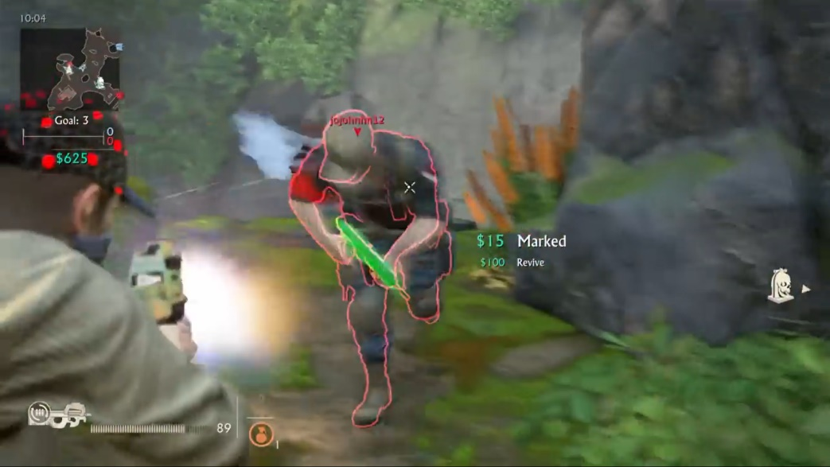
Killing enemies in the Plunder mode makes it easier to push towards the target treasure chest.

Interview Plan
Main points
- Microbit design
- CTF
- Augmented Reality Games
- Video games
Topic development
Microbit Design
- What do you know about the microbit?
- Would you play games with a microbit? Why?
- What could you do to improve the design of the microbit?
- What are your thoughts on having a CTF game mode implemented on a microbit that can be played with you and your friends? Are there any improvements you could think of?
CTF
- What rules do you know about CTF?
- Would you play CTF at your age?
- Where would you play CTF and why?
- How would you want to play CTF? Is there anything that you’d add?
- Would you play CTF on a microbit? Why?
Augmented Reality Games
- What is the first schema that comes to mind when you hear “Augmented Reality”
- Would you play an augmented reality game?
Video Games
- Would you prefer playing a video or augmented version of a game?
- What do you think of Uncharted 4’s Plunder Mode?
- What would you do to stop playing on your video game console, if you have one, to play CTF?
Case Study on Sami Messinezis (14 years old):
Microbit Design
- I know that the BBC made it and it’s a small computer that you can program to run the programs that you make
- Depending on what game it is. Interactive yes? Simple, like Tetris or Snake? No.
- It’s quite small. No protective casing and you can easily break it. There’s a lot of chips you can touch to mess up the whole thing
- I would definitely play it. The only problem is the interactive part. Would I have to press buttons or would there be a proximity or a pop up that allows me to capture the flag? Something like that. It’d be cool if you made an app for it but I think it might take a lot longer to produce.
CTF
- I think both teams, this is my knowledge of Call of Duty by the way, both teams have two flags at either end of the map. You literally have to get close to it, take it and then bring it back to your base and uh without getting caught. If you get caught, they’ll take and return the flag. I think it’s timed and points are rewarded
- Definitely. It’ll be fun
- At a park? Maybe a trampoline park as it’s much more places to hide the flag. However, there are a lot of safety precautions
- Like I said before. Something that notifies me. I can pass it to teammates.
- It depends. There should be a UI or it’d be weird to carry around. As I said, it’s easily breakable with many wires. There are a lot of safety precautions too such as water going on it.
Augmented Reality Games
- Virtual reality implemented in the real world through a screen
- To be honest I wouldn’t. There’s a lot of bugging and you would have to be in a certain area and lighting for the thing to work.
Video Games
- Video. You can do it in the comfort of your own home without outside conditions affecting it compared to augmented where everything has to be perfect.
- That’s pretty much capture the flag with a lot of rivalry. There’s a lot of shooting meaning you have to be cautious and you have to make sure you’re looking after your teammates, etc. etc.
- Has to have a UI. Interactive. Allow me to communicate with other teammates with nothing bugging out. It should flow very well. There would be a lot to be done for me to go from video games to CTF in real life.

Interview Data Review
Stability: There must be no errors mid game and everything should be seamless without having the need to reset microbits. Or, worst case scenario, restart the game.
Microbit: It’s too fragile to be held around whilst playing such a hyperactive game like Capture the Flag. Therefore, there must be some physical way to protect the computer. As Sami said, it’s a very delicate computer and is susceptible to many risks.
Software:
Should contain an instruction set on the UI that gives a briefing on how the microbit system works for the game.
Proximity levels should be proportional to the intensity of the light. Perhaps when the pixel starts flashing, it is safe to press the button to steal or place the flag.
Point system should be rewarded and displayed after every round. One round will be after a flag has been captured.
According to Sami, when the flag is retrieved from an enemy attacker, it must be taken back to base on foot, rather than having it sent back automatically.
I’d love the idea of passing the flags to other teammates. The ability to do this would probably be by the receiver who will press A to take the flag off team attackers. This may only be done by attackers.
A UI will most certainly be set up on the computer as it’d be way too simple and not as many options would be available. Furthermore, a mouse clicker would be a more convenient way to set up the game.
Environment:
It should definitely be noted that the game must not be in a trampoline park as the risk of injury is higher than a more open spaced area. A place such as a school park or even a school playground would be an ideal place as its flatter which allows the Bluetooth beacons to be set up.
Proposed Solution
Menu
The menu will be user friendly, ensuring that the stakeholders know exactly what to do. It will start up with a welcome screen that will have an input box, asking for the number of players in total. The first microbit will be connected to the computer the player will select if they’re an attacker or a defender and if they are in team one or two. The next microbit will be connected and so on. If all players in one team are attackers or defenders, the menu will kindly inform them that this is not possible and there should at least be one defender or attacker respectively. When all attackers have been captured, the next in line will be one of the defenders and will be selected at random. Another screen will appear asking for the number of rounds in the game. An options menu can be clicked on and with that, appears a set of defaults: there will be a maximum of 2 players in each jailhouse, there is no timer, you cannot hold the flag and capture teammates, there is a 3 second cooldown for capturing players who have just been freed from the jailhouse, an arrow will point to the enemy flag and the team flag is sent directly to base when obtained from enemy team. A new screen will appear, showing the rules of the game before it is safe to start playing.
Players
The attackers are the dogs of the game. They are usually the fastest and are the most strategic of the group. They are the only ones that can collect the flag from the enemy base. Attackers from the same team can take flags from each other and place it in their base. Only attackers can get sent to prison and can be freed by other attackers.
The defence have one objective: protect the team base. They cannot be a certain distance of the base as it’d be unfair on the enemy attackers. Once they are close enough, they can send enemy attackers to prison. The jailhouse will be chosen by the team members and there will be no Bluetooth beacons to show this. They have the ability to send flags back to base without having to go inside the circle of no entry. There will be another distance for the flags to be dropped off. An arrow will point to the enemy attackers that have the team flag and the defenders can steal flags off them. If the enemy attacker has the flag, the defence can simultaneously take the flag and send them to the jailhouse.
The bases on either side of the map will hold the flag for each team. Once the flag has successfully been taken from one end if the map to another, the base that had its map stolen will increment by one. It’s fixed at a certain position and once moved, that team is penalised.
Game ends
When the game ends, the results are stored back on the computer where the winner is declared or if there was a tiebreaker. These results will be stored on an external text file for persistent data storage. If there is a next match, then the results at the end of that match, accumulated with the results stored on the text file to see the high scores of the teams.
Controls
Attacker:
“Button A” – Take flag from enemy base / attacking teammates and free enemies
“Button B” – Place flag in base
Defence:
“Button A” – Take flag from enemy attackers and/or send to jailhouse
“Button B” – Place flag in base

Features for the proposed solution
Features explained
Features | Justification
Sound Effects | I believe sound effects are a great way to keep the theme of a lively experience.
Background music | The menu on the computer should have a nice arcade ambience to it such as a Mario based theme. This is because capture the flag is a pretty old, antique game and so should definitely have a fitting retro aspect to it
Pixelated Menu Screen | As the game is a less obsolete version of the original, I believe it should still come with its roots. As mentioned, with a retro based theme, the menu screen should be something eye catching that attracts my stakeholders yet something that shows some history of the game, therefore having a pixelated, arcade-like, screen.
Bluetooth beacons | Used as a more techno-based way of setting up the flag bases on either end of the team. No physical flag is required and will be shown on the attackers of team A and the defenders of team B and vice versa.
Microbit | A computer integral enough to be played around a playground with young children.

Software and Hardware Requirements:
Item | Justification
Microbit | The source code distributed will be available to the BBC: Microbit only.
Monitor | Screen that allows the player to configure options easily
Mouse | A pointer to navigate through the screen and click through the menu
Keyboard | For required input that goes into each microbit including whether they are attackers or defenders
Bluetooth beacons | See table above

Success Criteria
Requirement Specification
Requirement | Justification | Reference
Intensity of light is proportional to the distance needed for action to take place | So that players know when to correctly press the button without the need of having to enable the cool-down timer | Proposed solution
Game involves two teams, A and B | This creates competition during the game along with a scoring system that builds tension as to who is to win first to 5 points | Proposed solution
A smooth communication system between microbits | Makes the game easier to play rather than having to physically stop for radio communication to work properly. | Proposed solution
Button a and b have different functionalities depending on the type of microbit | So that different microbits have different pros and cons to make things fair and to disable any biases towards one microbit. | Proposed solution
A scoring system has been implemented for the bases and the masterbit both in-game and post-game respectively | So that a continued rivalry is in full effect between the two teams and with the help of knowing who has more points, can mean having to continue playing the game to that one team is more superior than the other. | Proposed solution
Every class has been made so that communications between every microbit possible has been established | To ensure the game works at its full functionality so that all microbits can communicate with each other through radio. | Proposed solution
Intensity of light is proportional to the distance needed for action to take place | So that players know when to correctly press the button without the need of having to enable the cool-down timer | Proposed solution

Design
System Diagram

Proposed screen design and usability features
Player State
Not in jail
If the attackers or defenders haven’t been captured by the opposing defenders, then all abilities that the attackers can normally do is still available. If you’re the attacker or defender, and you don’t have a flag, then your coordinate screen is what’s on the display. It’s their choice to decide whether they want to collect the flag or free attackers in their team.
When you have the flag

As the microbit has a 5x5 bit display, there can only be one icon on the screen that can only be changed whenever there is a change of behaviour. In this case, the flag symbol is the easiest way to tell an attacking player that they have obtained the flag. Defenders won’t need to have a different symbol if they take the flag, as they are only functional to retrieving unsuccessfully stolen flags. A red bit display will be the only colour available, but I can take this to my advantage as red is an eye-catching colour, especially for my young demographic. This screen will appear for a moment and will switch back to the coordinate plane where the flashing point will signify for any defenders on the other team.

MAP

If the attacking players do not have the flag, then it’s their main duty to search for it. For this to happen, the screen on the microbit will display a pixel, representing where the attacker is on the map. There will be a pixel representing the flag that will flash. There will be a faster flashing pixel to show that one or more attackers are in jail. This is so attackers can find their whereabouts and other points of interest on the map, but will not be too precise, as the microbit is too small for pinpoint precision. However, this can be taken as an advantage, as too precise of a map would make the game too easy to play. It will operate in real time using the compass integrated in the microbit. They will start working once both teams have pressed the “A” button on their microbit base. The default point that the players will be, regardless of where they are is the bottom left as shown to the left. This will be used as a relative point to a maximum of 50 meters along the x and y axis. Each adjacent square will be 10 meters from each other. The attackers can collect the flag once they are one square away to the flag square.
When defenders have the flag, the same coordinate plane appears, but instead, the coordinates that flashes will be the attackers that are surrounding them.

In Jail
If players do end up in jail, then all functionalities are blocked until either the game ends and there is a new game that begins, or another attacking player that isn’t in jail frees their ally. This attempted “X” is to signify that they have been blocked and it is the defender’s duty to make sure that the attacker goes to the jailhouse. As soon as they are freed, all functionalities are back to normal and the attacker can roam around again. As one player can be freed at a time, with a further 3 second cooldown, attacking players must be strategic into whom they decide to free.

A flaw about Capture the Flag being implemented on the microbit is that there are flawed visuals that won’t always appeal the target audience. The great advantage about the microbit however, is that it is a 5x5 display which keeps the game simple and not too complex for my demographic.

Scoring
The first team that successfully collects the first 5 flags, the game ends instantaneously, and a screen appears for all the players, showing who has won the game. This will be implemented through text horizontally scrolled across the microbit. The text will be either “Team A wins” or “Team B wins”, as partially displayed on the image on the left.
I would have to implement persistent data storage so that a high score system can be made so that whenever the players wish to see who has had the most points between both teams, the “main” microbit can be used to show this, through pressing button “A” or “B” to show the score for button A and B respectively.
This immediately brings a few problems to my project; there will only a scoring system for two fixed teams. The pre-built microbits provided will be for those players alone; the scoring system is based around those microbits.
Instructions
As the microbit is too simple of a computer to display the instructions of the game, the most efficient way to distribute it is via a physical copy of how to play. It will be pre-packaged when the kids want to play the game. Below is a rough idea of how the instruction sheet will look like. I have used big, eye-catching font to make it suited for my users and the exciting thrill that the game has to offer.
-----------------------------------------
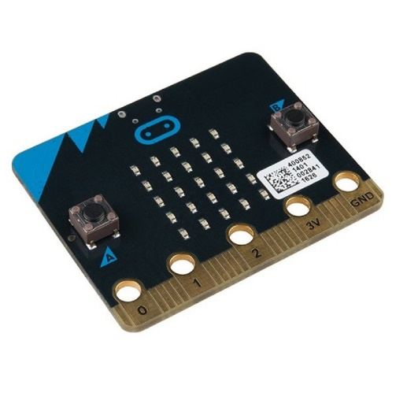
INSTRUCTION SHEET FOR CAPTURE THE FLAG ON THE MICROBIT
The buttons available on the Microbit is A (far left) and B (far right). There is a 3 second cooldown timer for every failed attempt. You must be one square away to successfully obtain what you’d like.
For the attacking team:
- A Steal flags and free attacking allies from jail
- B Place the flag in the team base
For the defence team:
- A Take flag from opposing players and send attacking foes to jail
- B Place flag back in base
The base microbits will be clearly labelled and should be on either ends of the arena. Note that because the microbits have been programmed to communicate at around 50 meters, make sure that your arena is not too big or your signal may be lost. Try using any objects as a barrier for your arena.
There will be a master microbit that tracks the total scores made for either team that can be shown only at the end of the game. Simply press A or B to display the results for team A and B respectively.
To end the game before first to 5 points, press the B button for both bases.
The flashing signal, being 2 flashes per second on the map will be
- Enemy flag if attacker and you don’t have the flag
- Enemy defence if attacker and you have the flag and home base
- Enemy attackers if defence
The faster flashing signal, being 4 flashes per second, on the map will be for the jailhouse
The flag symbol will appear if attacker or defender successfully obtains enemy or their flag back respectively.
-----------------------------------------

Summary of the process including key variables and structures
Microbits Attackers / Defenders
- Base
  - If button B is pressed for either base
    - End game
  - If button A is pressed for either base
    - Start game
- Master microbit
  - If button A is pressed
    - Show score for team A
  - If button B is pressed
    - Show score for team B
- Actions
  - Stealing flag from foe base
    - Unsuccessfully presses A
      - 3 second cooldown timer (CDT)
    - If attacker pixel and enemy flag pixel adjacent to each other
    - Presses A
      - Flag assigned to attacking player
  - Placing flag in team base
    - If flag retrieved by defender
      - Flag reassigned to defending player (attacker not in jail as a 3 second timer assigned to defender)
    - If not retrieved from defender
    - And unsuccessfully presses A
      - 3 second CDT
    - Attacker pixel and home base pixel adjacent to each other
    - Presses A
      - Point increment using the score function
  - Free allies from jail
    - Unsuccessfully presses B
      - 3 second CDT
    - If attacker pixel and enemy jailhouse pixel adjacent to each other
    - Presses B
      - Closest person to attacker free and functionalities back up again
      - 3 second CDT
  - Capture attackers
    - Unsuccessfully presses A
      - 3 second CDT
    - If defender pixel and enemy attacker adjacent to each other
    - And presses A
      - Attacker functionalities blocked (must be physically sent to the jailhouse)
  - Retrieve flag
    - Unsuccessfully presses A
      - 3 second cooldown timer (CDT)
    - If defender pixel and team flag pixel adjacent to each other
    - Presses A
      - Flag assigned to defender player
  - Placing flag in team base
    - Unsuccessfully presses B
      - 3 second cooldown timer (CDT)
    - If defender pixel and team base adjacent to each other
    - And presses B
      - Flag assigned to base
Cooldown Time
- If button A is pressed
- There is no adjacent pixels
  - Set cooldown timer for 3 seconds
Controls
- Button A
  - Obtain flags and people
- Button B
  - Place flag in base

Game State
- Assign microbit bases to zero
- If enemy flag goes to team base
  - Increment point on team base
- If defending players too close to base after 4 warnings
  - Remove one point every time onwards
  - Repeat every two seconds
  - All functionalities
Scoring
- Send scores of both teams to master microbit
- Compare both scores
  - If team A greater score than team B
    - Declare team A the winner
    - Send information to all player microbits
  - Else
    - Declare team B the winner
    - Send information to all player microbits
Test data for development
Actions
Stealing Flag
Test Data | Type
A | Valid
B | Invalid

Placing flag in team base
Test Data | Type
A | Invalid
B | Valid

Free allies from jail
Test Data | Type
A | Valid
B | Invalid

Capture attackers
Test Data | Type
A | Invalid
B | Valid

Retrieve Flag
Test Data | Type
A | Invalid
B | Valid

Placing flag in team base
Test Data | Type
A | Valid
B | Invalid

Test data for beta testing
Test number | What is being tested | Input/action | Expected outcome
A | Actions | Buttons | Action executed successfully
1 | Steal flag / free players from jail / Send players to jail | Valid : A button when player is attacker or defender and pixels adjacent to each other  Invalid: B button pressed by accident | Valid: Action successfully executed with symbol displayed on screen depending on action  Invalid: 3 second cooldown timer
2 | Place flag in base | Valid: B button when player is attacker or defender and has flag to themselves and pixels adjacent to each other  Invalid: A button pressed by accident | Valid: Place flag in base  Invalid: 3 second cooldown timer
B | Coordinates | Movement | Pixel on screen to show where player is on the map
1 | Base coordinates | Valid: Base distance less than or equal to 50 meters to each other  Invalid: Base distance more than 50 meters to each other | Valid: Players can see where flag initially is (i.e. the base)  Invalid: Game will not begin until the bases are closer to each other
2 | Player coordinates | Valid: Players are within the arena size  Invalid: Players are beyond the arena size | Valid: Players can see their pixel appear on the microbit screen  Invalid: Players cannot see themselves on the map

What’s being tested | Input | Justify | Outcome | How to solve
Does each microbit work as instructed? | A | To ensure that each microbit will have different outcomes | Attack – Steal  Defend – Steal/Send to jail  Base – Start game  Masterbit – Score for team A | NA
Does each microbit work as instructed? | B | To ensure that each microbit will have different outcomes | Attack – -Place  Defend – place  Base – End before first to five  Masterbit – Score for team B | NA
Is the flag assigned to someone else when stolen from? | A | To see if someone who holds the flag initially loses it and is assigned to the person that steals it | Works for attack/defence | NA
Base incrementing/decrementing | B | To see if the base increments the score by one if a flag is placed | It’s stored but no change in score | Create a new function with a while loop to check if there is a change in flags, to then increment the score on that base by one

Players
Steal Flag/Player
Attacker (just flag) / Defender (flag/player)
Test data | Type
A | Valid
B | Invalid

Place Flag
Attacker / Defender
Test data | Type
A | Invalid
B | Valid

Turns
Test data | Type
NA | NA
Controls
Start
Test data | Type
A (Base) | Valid
B (Base) | Invalid

End before first to 5
Test data | Type
A (Base) | Invalid
B (Base) | Valid

Score
Test data | Type
A(Masterbit) | Valid
B(Masterbit) | Invalid

SDLC PROCESS
Waterfall Development
Majority of my project will include the key features of a waterfall life cycle including my problem recognition, analysis, design, development and implementation; each “block” is dependent on whatever is above it and nothing more.
Agile Methodology
It includes a collection of methods and brings a lot of flexibility to my project. If I ever need to go over something that I hadn’t completed to the highest standard, I could go over it. By getting constant feedback from my users, I get to maintain my project to its fullest. My preference is by starting off with a waterfall development, But after my evaluation has been checked against my criteria, I will go over my code again and look for any ways it could be improved and even go over my analysis and check certain areas that I didn’t have time to complete within my timeframe

Development

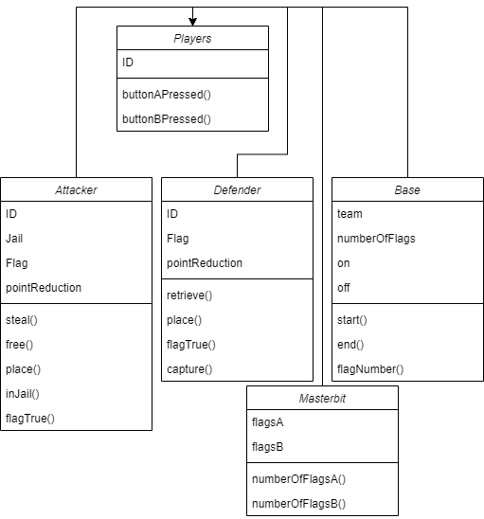
This is a current representation of the classes needed for my project. However, it is not in its final level as there are other classes required to initialise the game for instance, and use radio functions to establish communications between two microbits.

Game Basics/ Setup
Declaring global variables, classes and methods for my radio function.
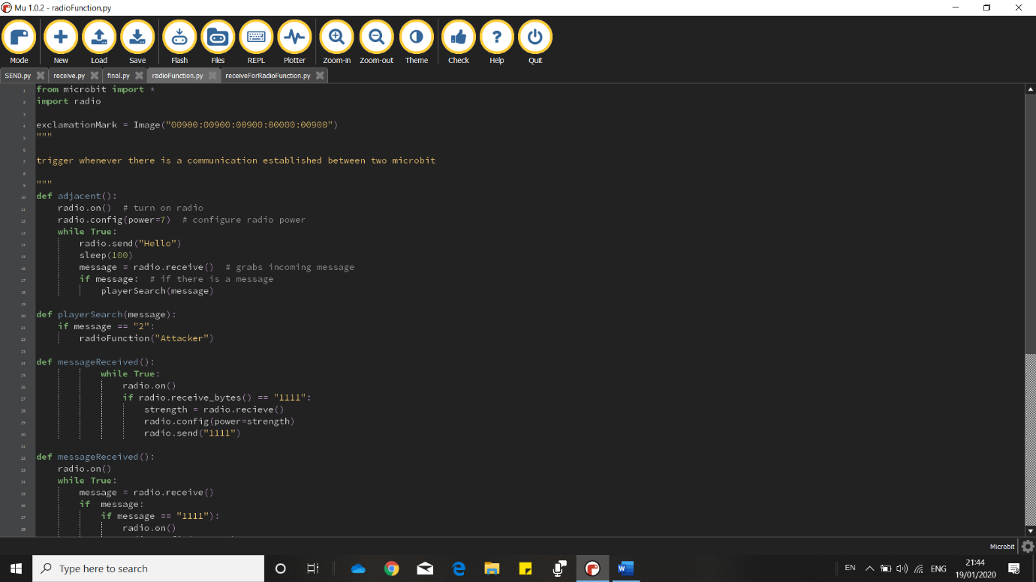
The numbers correspond to the line number
1 – This allows me to import all the functions available on the microbit library so that my code is compatible on a microbit computer
2 – This code allows me to run all functions in the radio library that isn’t in the microbit library to allow my microbits to communicate with each other
4 – When called, this line of code will display an exclamation mark on the microbit that called it to signal that there is a “complement” microbit near them
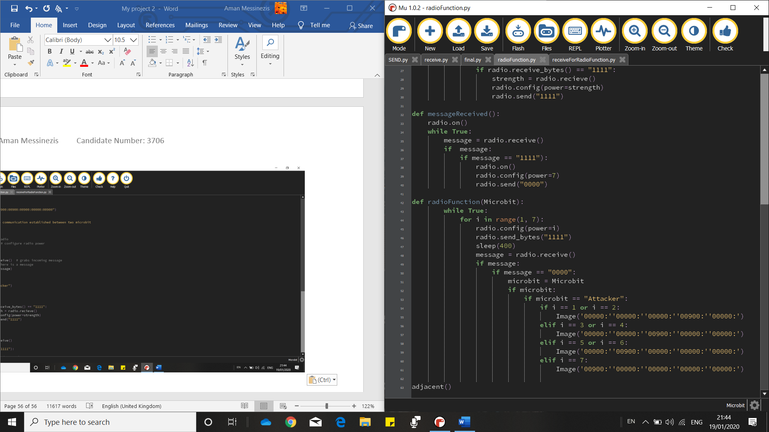
10 – This function is one of many functions that make up communication between two microbits. What this one does however is check whether there are any microbits nearby. If there is, the function will move on the next method, playerSearch(). The reason why these cannot be held within a class is because methods cannot call other methods within the same class. So instead, I have kept these functions within the same file, to give the idea that it is a class
In order for any of my radio functions to work, they must be turned on. They are default is off so that the microbit can conserve battery life.
My while loop is set to loop forever which checks if the following conditions are met which in turn, actions are applied. The sent message “Hello” is arbitrary and is a way for microbits that have a receive function to look out for any other microbits that are saying hello. If there is a message back, it Is then passed to the playerSearch function.
16 – This line of code grabs the next message in the queue held in the microbit.
20 – This function compares whether the message that was grabbed in the adjacent function was called “message”. It was sent using a function on a different file for a different microbit.
The if statement used compares the message passed form the adjacent function to a set of conditions that if true, will be sent to the radioFunction function. However, my playerSearch function only has one condition, being if the message is 2, then this maps to “Attacker”. There will have to be future conditions such as if the microbit is a defender, or a base, or the jailhouse.
42 – This function takes Microbit as the parameter. It’s supposed to display a pixel on the microbit to show how near “complement” microbits are to them.
What is being tested? | Input | Justification | Outcome | How to solve issues if there are any
My radio function. If there is an exclamation mark on the screen when the send to receive microbit shows an exclamation mark when close to the receive to send microbit. | Microbit at variable distances | To see if there’s an exclamation mark when the microbits are close enough | See video 15 | Syntax error line 37 radioFunction.py() file  Resolved  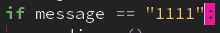
“ | “ | “ | See video 13 | Value error line 12 receiveForRadioFunction.py() file  Resolved  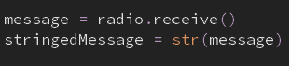
“ | “ | “ | Nothing displayed
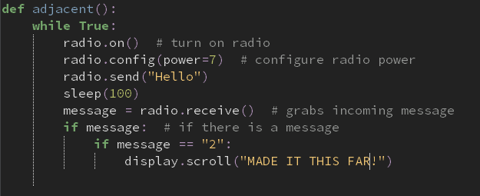
I adjusted my adjacent function in the worries of thinking that it wasn’t working. To make sure everything was going accordingly, I ended my radio functions at the end of my adjacent function where it will scroll “MADE IT THIS FAR” so that I knew that it was working accordingly. If not, I’ll know that there must be an issue with my adjacent function.
What is being tested? | Input | Justification | Outcome | How to solve issues if there are any
My radio function. If there is an exclamation mark on the screen when the send to receive microbit shows an exclamation mark when close to the receive to send microbit. | Microbit at variable distances | To see if there’s an exclamation mark when the microbits are close enough | See video 12

I figured that there was no point in having my playerSearch function as it could just be merged with my adjacent function, plus it only has very few lines of code.
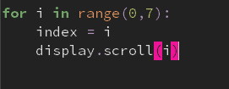
I did some code analysis for a for loop to see if that was the issue in the radioFunction function for my set of radio functions to withstand a communication as well as an exclamation mark to signal nearby complement microbits. I did this by creating a basic for loop which will display 0 to 6 on the microbit. By using an index, initially i which goes from 0 to 6, and gets displayed across the screen, then i is incremented by one. If you see video 12, you can see that it does work.
However, I wanted to adjust my for loop to see if it would work once a condition is met. This is via a while True loop which should wait until button a is pressed for my index to be scrolled across the microbit.
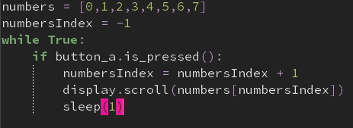
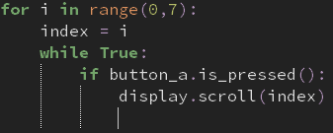
However, video 10 shows that only zero is displayed, which could imply that that’s what’s happening in my main code, and therefore, won’t properly work.

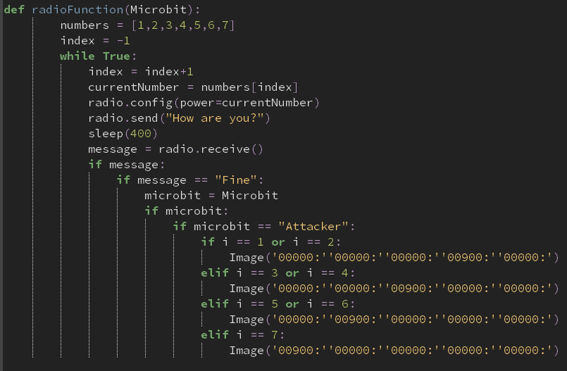
A way that I got around this is by making a queue which would be checked through a pointer. Video 9 shows that this works even with a condition applied. The queue called numbers goes from 0 to 7, and also comes with a pointer called numbersIndex that points to -1 first. My while True loop checks for a condition to be met, being if button a is pressed. If it is, my numbersIndex variable gets incremented by one.

I changed my for loop into the format that involves using a queue and a pointer

What is being tested? | Input | Justification | Outcome | How to solve issues if there are any
My radio function. If there is an exclamation mark on the screen when the send to receive microbit shows an exclamation mark when close to the receive to send microbit. | Microbit at variable distances | To see if there’s an exclamation mark when the microbits are close enough | Value error at line 11 | I haven’t turned on my radio.  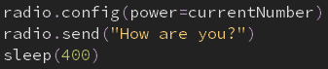  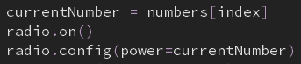
“” | “” | “” | Index error line 9 | I did not have an end to my implicit for loop. So, when index is greater than 6, I should end my function  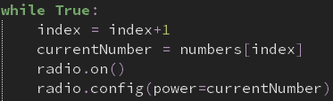  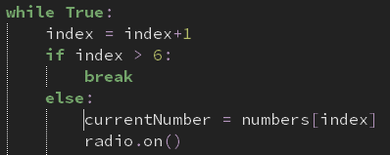
 |  |  | Blank display
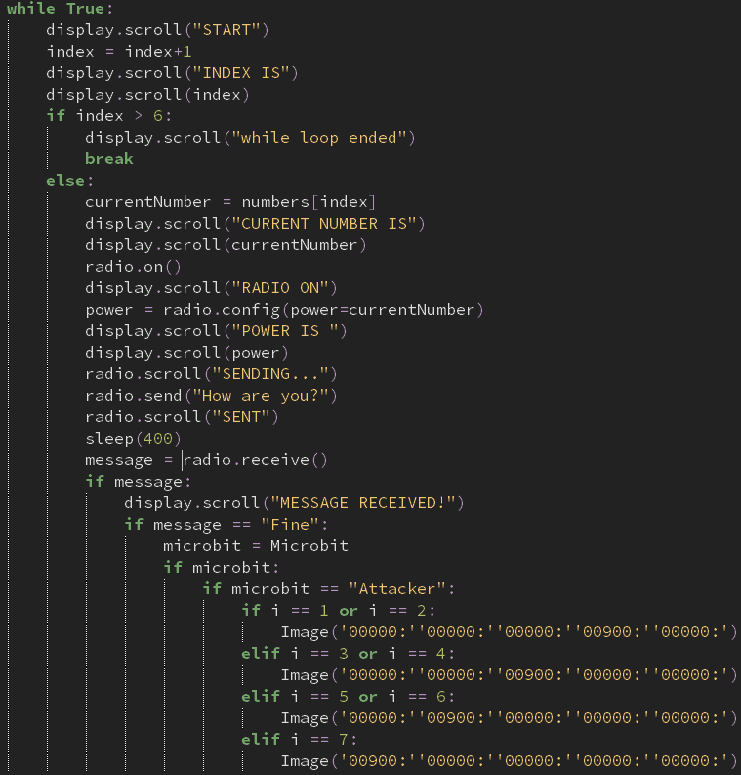
I decided to break my radioFunction down even further and see if certain lines were going accordingly. I did this by scrolling text across my screen at different sections of my function so I can pinpoint where I went wrong.

What is being tested? | Input | Justification | Outcome | How to solve issues if there are any
The radioFunction() | Receive to send microbit | Sends a message to the send to receive microbit which has the radioFunction | Attribute error at line 23 | Change radio.scroll to display.scroll  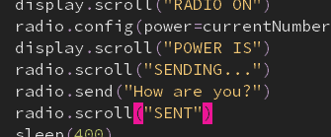  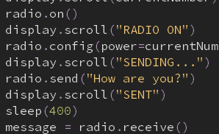
 |  |  | Name error at line 33 | Change i to index  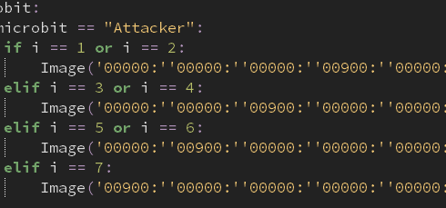
 |  |  | It doesn’t display a point on the microbit | Make a different function that displays the point on the map  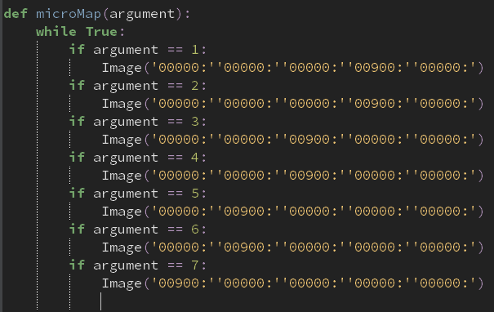
 |  |  | The micromap function isn’t defined | Work on the micromap function in isolation from the rest of the program
Micromap() to see if an coordinate is displayed on the microbit | Receive to send microbit | Send a message to the send to receive microbit | No image | Use the display.show() function  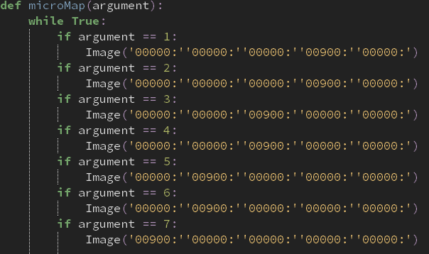  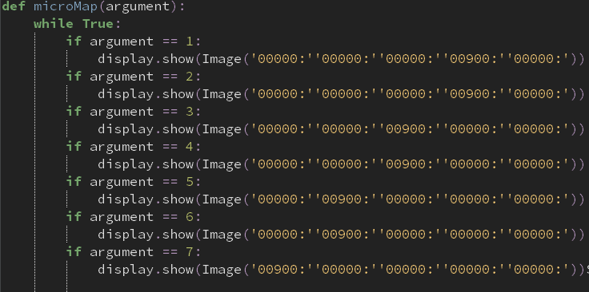
 |  |  | Works! A pixel is displayed at the second row of the microbit when 2 is the argument used. See video | Merge both functions together

It was working, as shown in the video, yet for it to be a loop that is checked forever, I wanted to edit my code in such a way for this to happen.
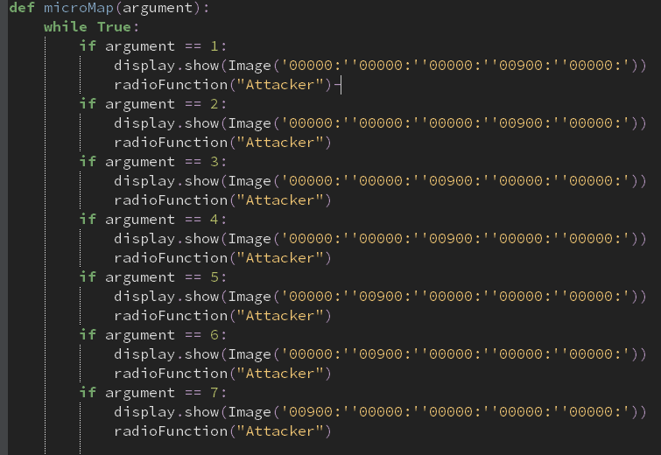
radioFunction(“Attacker”) was put under all my if conditions so that when any of them are me, the radioFunction gets called again. This would be a recursive method, which may lead to a stack overflow error. In addition, I couldn’t simply let the while loop in my radioFunction loop to be used as it and the microMap function are two separate functions.

What is being tested? | Input | Justification | Outcome | How to solve issues if there are any
The robustness of my function | Receive to send microbit | So it can send off a signal to me send receive microbit which is then delegated to the radioFunction | See video… I got a runtime error in line 30. | Perhaps merge my two functions in a way that it would only require one function so a while loop can still work out.
 |  |  | See video… the pixel moved to the top of the microbit display even without having a change in radio strength | Assign index to -1 once an image has been displayed  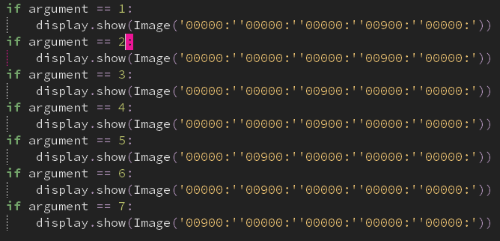
 |  |  | See video! Working
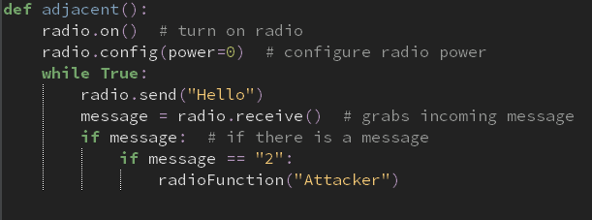
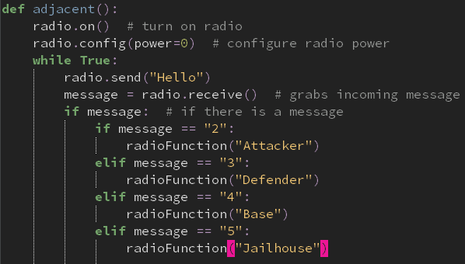
My adjacent function establishes a connection between two microbits and passes a value to the radioFunction() function, depending on what message is sent back. However, it hasn’t been fully validated as it hasn’t taken conditions from all types of microbits
The updated code, from line 10 onwards, allows validation from different types of messages that are sent back to the send-received microbit.

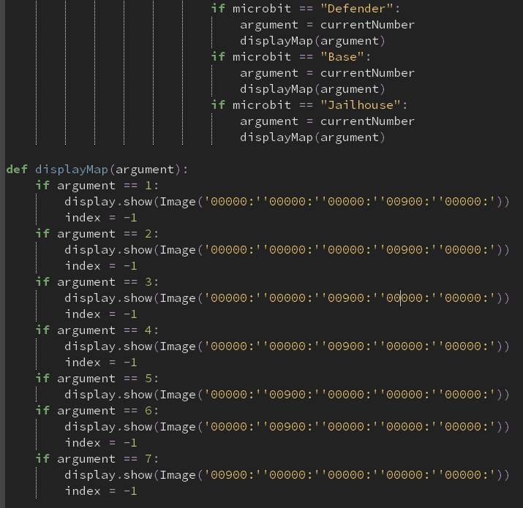
I wanted to further develop my code by creating a function that would essentially be its own subroutine to display an image on the microbit screen, depending on whatever argument is passed to the function. However, I noticed that it wouldn’t work because the index variable wouldn’t be understood by the function. The purpose of that variable is to change the pointer in the list in the radioFunction() subroutine is to -1, so that it can loop through the list again.

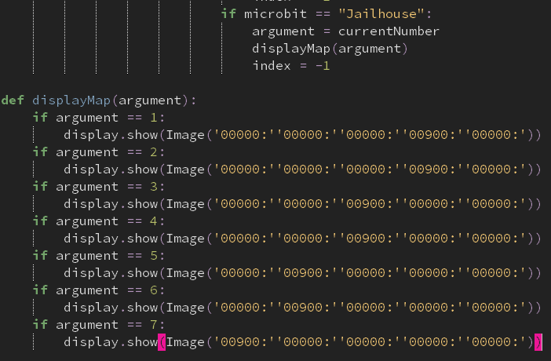
The following is a revised version of the code above. I have improved it by removing the index variable and moved it so that it is within my radioFunction subroutine, and also keeping my displayMap function so that it can be called from anywhere in the program without the need of “messy” code.

What is being tested? | Input | Justification | Outcome | How to solve issues if there are any
radioFunction with the addition of the displayMap subroutine | Receive send microbit | To send a message to the send receive microbit which has the radioFunction and the displayMap function | Empty screen | Remove the displayMap function and insert the code within that subroutine in the radioFunction subroutine. This is so I can have a good understanding with which function is not working.  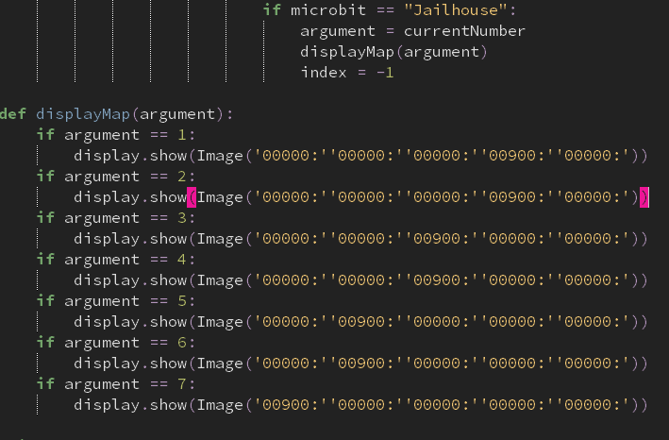
 |  |  | Empty screen | Perhaps by backtracking and comparing both functions before adding other microbit conditions in the adjacent and radioFunction subroutines
 |  |  | Working solution again | 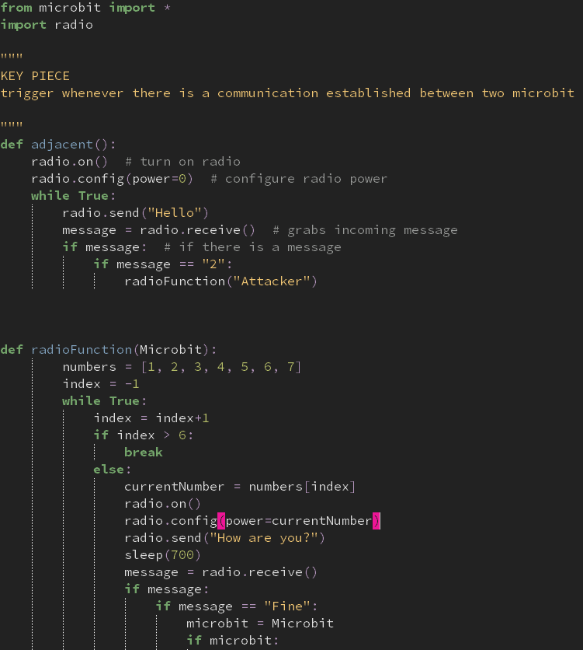  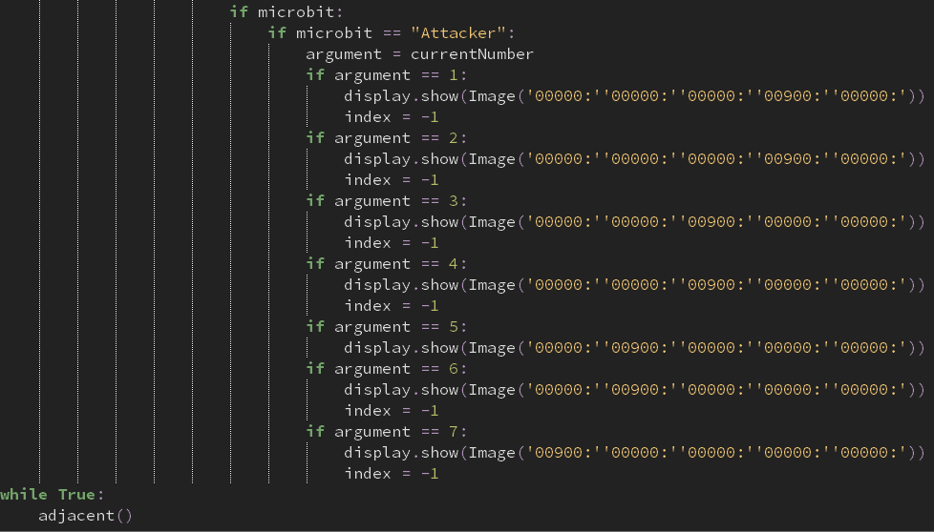  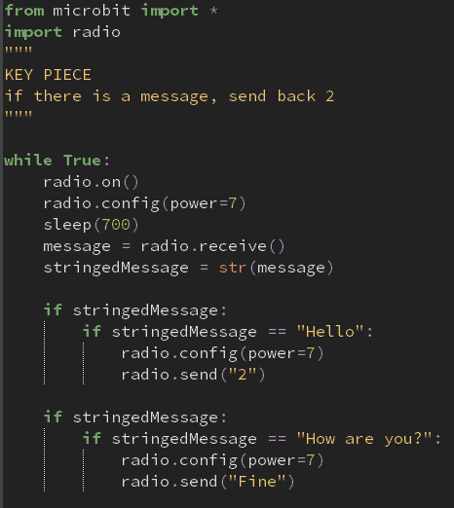  The following coded solutions show my radioFunction, adjacent, and the functions used in my receiveforRadioFunction are all working accordingly.  My next steps are to implement more conditions to the rest of my program wherever needed to make it flexible for all types of microbits.

There were slight errors to my display when compiled. I created trace lines of code so I could see what values were being passed through my microMap function. The video footage had shown that there were numbers being passed that shouldn’t have been. I decided to go back to my radioFunction and debug the issue as I knew that that was what was going on. I was going to trace through my code so that I could hopefully pinpoint where I went wrong.
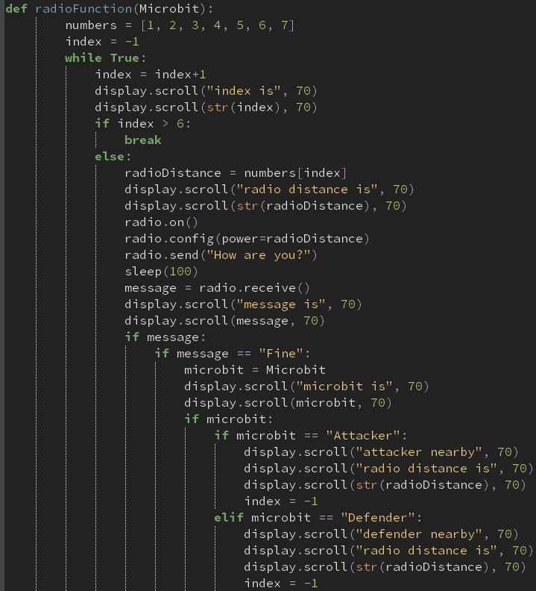
This screenshot is my radioFunction, still with the same code. The only difference is that I’ve inserted more lines of code so that I get a good understand of what all my variables are assigned to, especially how they change during the while loop

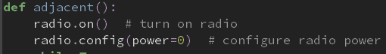
I realised that I had configured my radio to 0, so no message was sent at all!
Furthermore, I got a memory error when converting my python code into readable bytecode for my microbit to understand, due to the RAM running out of space. For this reason, I’ve currently removed all comments and deleted sections of my code to free space.
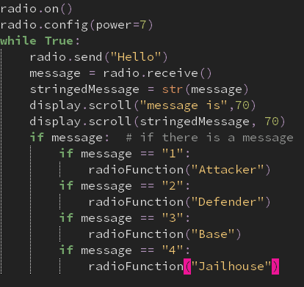
My send to receive microbit was also not receiving messages. I spotted the error that I hadn’t put the microbit to sleep, as it does have to wait for a message to get sent to its queue. The screenshot below is a developed version of the code to the left.
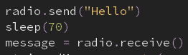

I successfully resolved the error of having different indexes. The main reason was due to the fact that there had to be a button that was pressed for the send receive microbit to be activated. Or else, the receive send microbit wouldn’t be receiving anything and would return None to the send receive microbit.
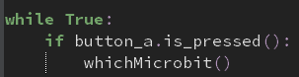

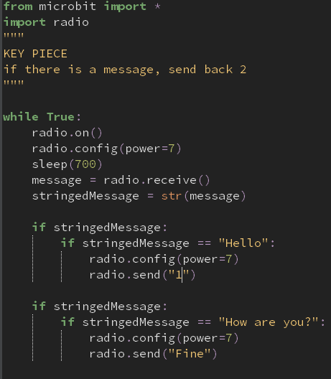
The following code screenshots show different receiving functions from different microbits. The reason why I made this is so that my microbits could receive radio communications not just from one microbit, but several. Right now, the main problem I’m facing is threading several files so that it can work seamlessly within my microbit display screen. Currently, there is only a pixel that is displayed on the middle x axis and moves in the y direction depending on the distance between the microbits; it’ll be difficult to include different microbits on the screen without the game being too confusing. Worst case scenario would be having only one pixel, but detects the closest microbit to them, and that’s what’s focussed on. I also need to be aware of the “complement” microbits (i.e. attackers will complement the opposition base and defence microbits, and the defence microbits will complement the attacking microbits from the other team.
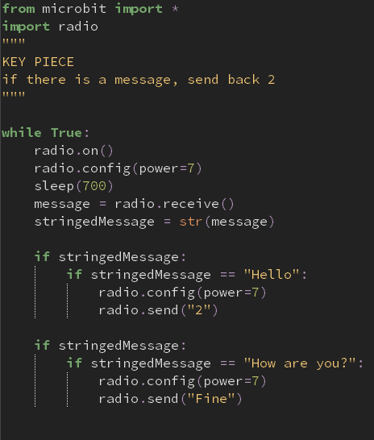
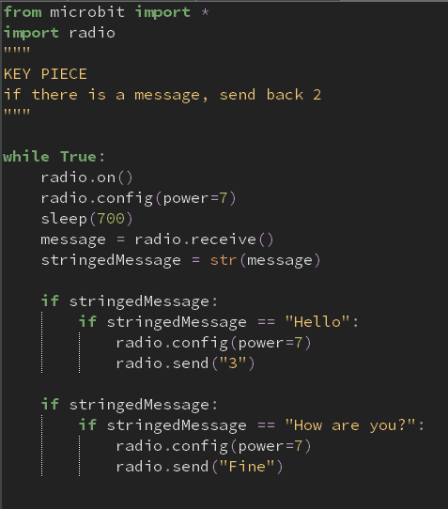
What I have done to test these files to see I know that the correct one is being run once compiled is to adjust the brightness of the pixel on the screen, depending on which microbit receive file is being used.

What are you testing | Input | Justify | Outcome | How to improve
microMap function | 3, Attacker | To see if the correct brightness as well as the location of the pixel is displayed | See video  The brightest pixel intensity in the correct location | NA
 | 1, Jailhouse |  | See video  The weakest pixel intensity in the correct location | NA

Now that I have a clear understanding that my subroutine is working accordingly, I can minimise the size of it as intensity was just a way for me to know that the code points to the right location, and it is working accordingly.
See video for a full working version of the radioFunction
The radioFunction is officially working.
Review
What has been done
I have created a minimap for attackers and defenders using the built-in radio functions that the microbit has to offer by importing the radio library. The way I have successfully established this is by having the microbit loop through radio strengths 1 to 7, 1 being the weakest and 7 being the strongest, and whenever there is a microbit nearby, that is of a certain relationship to the microbit using the radio function , then this is passed to a method in the players class which then displays a red pixel on the microbit screen.
How it has been tested
I have video evidence showing any failed versions of this function as well as successful versions that have been worked upon. A technique that I used to help me work through my code was by adding a tracing algorithm which essentially made me pinpoint where my errors were in my code so I can work around it. When testing, I needed two microbits. One that uses the radio function, the “host”, and the other that sends the host a message whenever there is successful communication between both microbits, the “guest”. The guest microbit would stay in a fixed position and I had to physically move myself at different distances to ensure that the host microbit would move its pixel up and down across the middle of the x axis depending on the distance of the host and guest microbit.
How it meets my success criteria and user expectations
One of my user requirements is to create a minimap for the players to see where their targets or foes are. For example, an attacker will see the enemy base where the flag is being held when they do not have it. The players will be able to know where things are with ease as well as know if enemies are nearby.
Criteria being met are ensuring that radio communication has been made and the creation of a minimap for all players.
Changes in the design that have resulted from this section
My minimap has been altered in such a way so that there will only be one pixel that will be displayed on the microbit screen as I found it too challenging to have another pixel within the same while loop. Furthermore, instead of the pixel moving along the display to show a rough idea where they are in real life, due to not having enough time to focus on this section of code for too long, I had to alter the way the pixel would behave on the screen. It would have to move up and down on the centre x axis, and the closer it is to the x axis, the closer that microbit is to that host player.
Summary of the whole project as a prototype at this stage
When compiling the radio communication functions for the sender and receiver, there will be a pixel displayed on the centre x axis and will move up and down depending on how close the microbits are to each other.

The following program will consist of an object-oriented based strategy of creating my players. The reason why I’m using object-oriented programming to do this is because it can bind together the data and the functions that operate on them so that no other part of the code can access this data except that function. Attackers, defenders, bases, jailhouses and the masterbit all funnel through to be the “characters” of the CTF game. I would need to create characters that require slight altercations. For example, the only difference between the attacking microbits is the unique ID given to them; everything else is the same: methods and data they hold. To reduce the number of code needed to be written, object-oriented code keeps my project easy to work with. And if I need to alter a character in my game, rather than having to go through all 8 attacking programs, as there will be 8 attackers shared between teams A and B, using object-oriented programming allows me to work with it on one file.
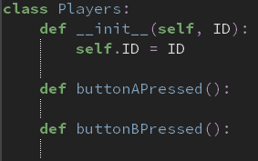
My parent class called Players will hold the ID of any instance that uses the Players class, and will be used across the rest of the classes within my parent class, Players, called sub-classes. My sub-classes will consist of the characters within the CTF game, acting as a blueprint to create the actual object code.
The self.ID line will allow me to refer to the current instance of the class, and is used to access variables that belong to the class. So therefore, I will be assigning whatever ID is passed in my Players class, directly or indirectly, as the instance of the class’ ID.
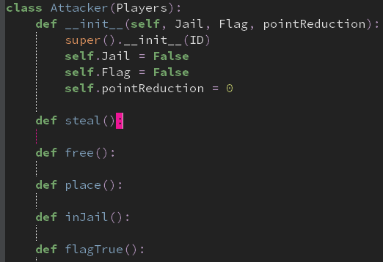
The child class Attacker is a sub-class of the ancestor Players, as displayed in brackets in the first line, as well as in the third line. The reason why I had to state this twice is because python syntax makes it no longer possible for Attacker to inherit the Players __init__ function, as another __init__ function is used in the Attacker class, overriding whatever is in Attacker’s parent class. The only way to inherit the parent’s __init__ function is to add a call to the parent’s __init__ function within the child __init__ function. This allows it to inherit data within the Players class, which is ID.
Attacker further comes with Jail, Flag and pointReduction given as the data within that class. These parameters are used to access functionalities within the Attacker class, i.e. steal, free, place, inJail, and flagTrue.
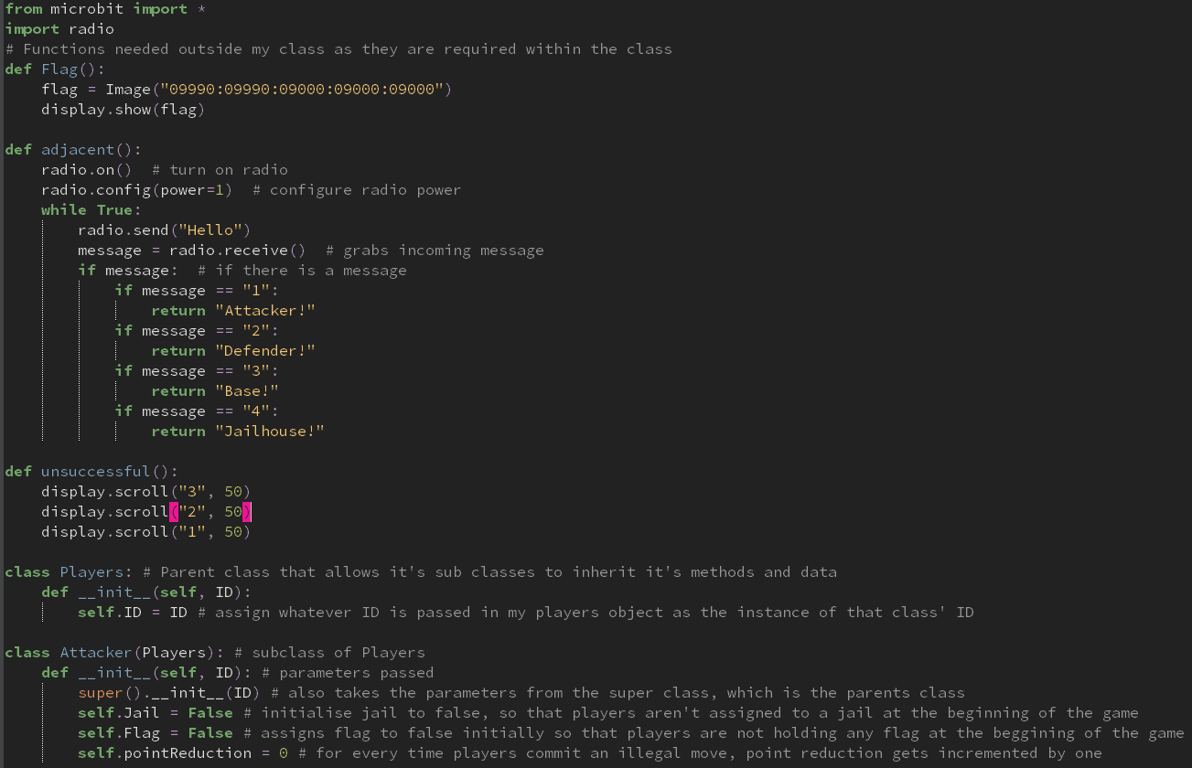
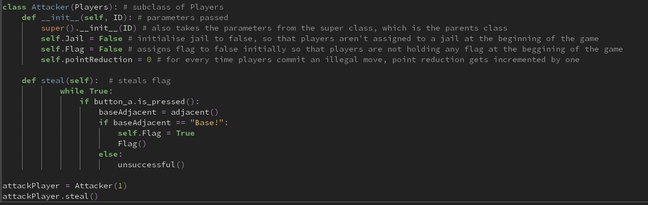
The screenshots above show a developed version to my Players class. It only consists of the parent class, Players, as well as an Attacker sub-class. It also has two new functions called adjacent and unsuccessful. Adjacent is a polymorphed version of my whichMicrobit function used in my radioFunction, only that the power is assigned to one. I did this because the only way that a flag can be stolen is if both players are at a very close distance. Power=1 achieves this criterion for my steal method in my Attackers class as it requires a close distance for the method to be true. The unsuccessful function simply displays 3, 2, 1. The reason why I defined this function is because it acts like a cooldown timer, only when certain conditions are met. For example. If players aren’t close enough, which they will know as it’s displayed on their screen, the cooldown timer will be initiated. This is a great way to eliminate any cheating, by repeatedly pressing A, in hope that they will steal a flag. Olivia, one of my stakeholders tested this function out and she believed that the cooldown way too quick, and in order to keep the game’s tense vibes, it should slightly be altered. Therefore, we both agreed on a duration of 150milliseconds from 250 milliseconds.
What am I testing | Input | Justification | Outcome | Improvements needed?
Steal function | Button_a and defender | To see if the desired outcome is displayed on the microbit screen that presses A | “Unsuccessful” function displayed, see video | NA
Steal function | Button_a and base |  | Flag displayed, video | NA

Review
What has been done
I’ve made a steal function with the defender class that steals the flag that an attacker was holding. I did this by assigning the flag to true to the defender and false for the attacker who were previously assigned false and true respectively. This will only happen if the attacker does have a flag. If the attacker doesn’t have the flag, then a cooldown timer will be initiated.
How it has been tested
I used video evidence to show that my method was working. To see if the flag was actually assigned to the defender and snatched from the attacker, then there will be a tracing algorithm to show that this has happened. When button a is pressed from the defender microbit, then a flag will disappear from the attacker’s screen.
How it meets the success criteria and user expectations
Capture the flag requires flags to be stolen and retrieved so that they can be placed in bases to gain points. For the game to work on an algorithm, I would need to make this happen computationally
The success criteria that it meets is:
- Create a steal function
Changes In the design that have resulted from this section
There have been no changes
Summary of the whole project as a prototype at this stage
I have completed a radio communication system that allows microbits to find out if they are adjacent with one another, a minimap displayed on their screen, and a stealing function for attackers and defenders.

Defender is a subclass of Players, by inheriting the ID attribute. It takes two parameters, flag and the ID, which is retreived via Players superclass. The initialised variables it holds are Flag and Pointreduction. The reason why flag is assigned as false is because at the beginning of the game, the flag is held in the base, and will be assigned to true later in the game when they steal the flag from attackers from the other team. Point reduction will increase if defenders commit an illegal move such as stepping inside the radius of the base or the jailhouse, to prevent cheating.

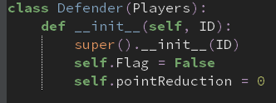

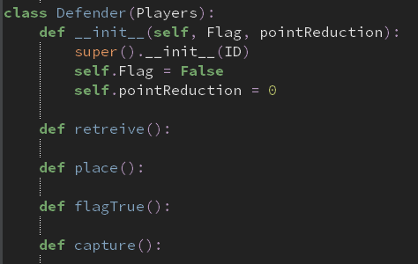

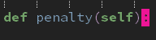

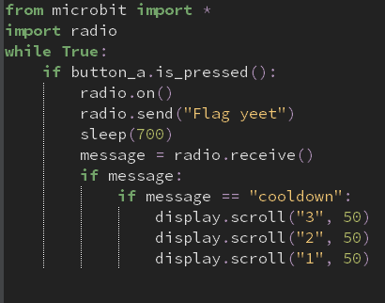
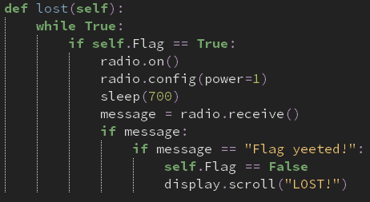
As my analysis explains how the defender’s objective is to protect their base from enemy attackers stealing flags from them, stealing flags is a way for these defenders to redeem themselves for having the attacker stealing the flag in the first place. This lost method is called when a radio signal is sent to the attacker with the flag from the defender who has successfully retrieved the flag back from the enemy team. I used a while loop so that the block within my method is checked an infinite amount of times whenever it’s called during my program. It checks whether the current attack object has the flag. If this is the case, it then checks whether there’s been there’s a message sent to them. If “Flag yeeted” is what’s received, then the program gives up the flag and sends it back to the opposing team’s defender
What I’ve done to test this is by creating a few lines of code that, when a is pressed, attempts to steal the flag from the person holding the flag and sends a message which is altered for the sake of development purposes. A cooldown is initiated if the attacker doesn’t have the flag.

What’s been tested | Input | Justification | Output | How to solve problems if there are any
Lost method | Attack set to flag is true  Defence pressing button a at a close distance | To see if the attack object has flag set to false when retrieved from opposing defence | See video | NA
 | Attack set to flag is false  Defence pressing button a at a close distance | See that my first if statement works | See video | NA
 | Attack set to flag is true  Base pressing button a at a close distance | To see if the message received is what triggers “LOST!” to be displayed | See video | I forgot to assign flag to False after changing it to false in the previous testing
 |  |  | See video | NA

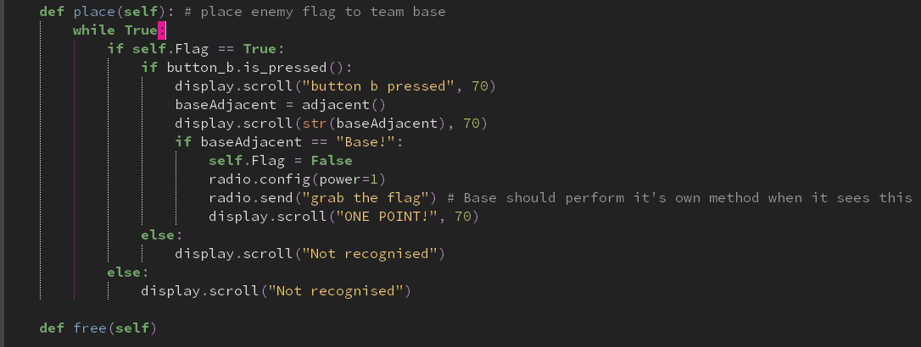
In the breakdown of my problem, I explain how attacking players, when the flag is assigned to the, have to place the flag in their base without getting caught by defenders. The place method within my Attack class within my Players class allows them to do so. When the b button is pressed, the adjacent function is called which is in the same file as the rest of my Players sub class. If the base function is returned, the flag that the attack initially holds and was set to true gets set to false. Radio communication allows my attack microbit to tell the base microbit to increment it’s number of flags variable by one. I have made my code robust by using validation techniques so that pretty much all input will return an appropriate output. If the attack doesn’t hold a flag initially, then the screen of the attacker’s microbit will display not recognised, as well as when button b is pressed. For the sake of testing, I have added trace statements throughout my method to see how variables are initialised to and also see where I have gone wrong in my program.
What am I testing | Input | Justification | Output | Improvements needed? If so, what are they
Place method | Base | It’s a condition needed to allow the attack microbit to tell the base microbit to grab the flag | “Not recognised” displayed on screen  See video | Remove the first else statement as button b would have to be pressed instantaneously for that statement to not be passed  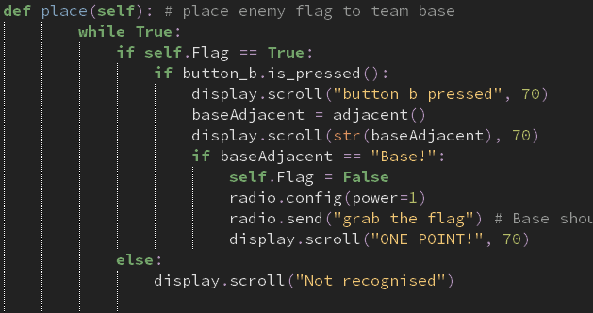
 |  |  | It goes all the way to “ONE POINT!” however also displays “Not recognised”  See video | The reason why it displays the else statement is because my place method is a while statement and will always check through. Therefore, when self.Flag is assigned to false, meaning that the attacker doesn’t have the flag, that’s the new assignment. This then would have to mean that when it’s looped the second time, it would have to pass “not recognised”. In conclusion, the only way for this to not happen is to remove my else statement  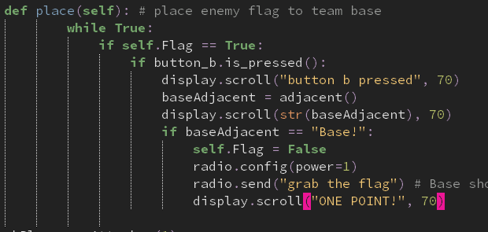
 |  |  | Goes all the way to “ONE POINT!” with no other statement s after  See video | As I know that it’s working accordingly, I now have to remove my tracing statements such as “ONE POINT!” and actually use another function to set the points within each Base class.
 |  |  | MemoryError on Base microbit.  See video | Try removing as many whitespace and comments when possible.
 |  |  | “Not recognised” displayed and when button b is pressed, no change in display | Perhaps changing the else statements so I can recognise where my error is  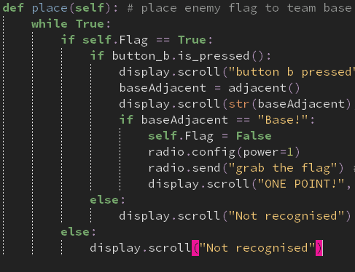
 |  |  | By deleting both else statements, my attackerBit was working. However, the message sent was “None”. | Noticed that the attackBit was sending “grab the flag” whilst the baseBit was looking for “FLAG!” to be received on their end.
 |  |  | “None” is the message returned and displayed on screen, using the tracing algorithm | There isn’t a number assigned to the baseBit which corresponds to a microbit for the adjacent function  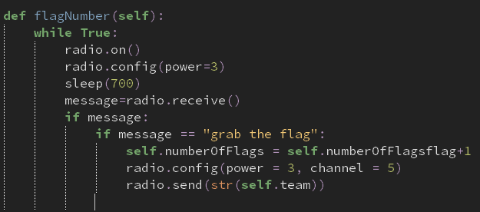  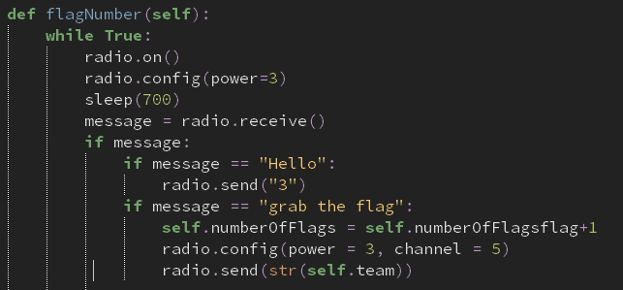
 |  |  | “ | No batteries
 |  |  | Attribute error at line | I forgot to assign an instance variable in my __init__ method called “numberOfFlags”
 |  |  | See video – Works | NA

The place method in the attack class and the flagNumber method in the Base class are working!

Review
What has been done
I have created a method called place that allows attackers and defenders to place flags in their own base. I created a while loop so that the program can check through this block of code an infinite amount of times as soon as the program starts. Radio communication is requires for the base to increment it’s number of flags that it holds and to also change the value of self.flag to false.
How

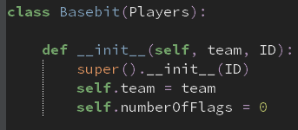
Base is a subclass of the Players class. The purpose of this class is to store the flags that are retrieved in game, as well as when flags are stolen. Initially, the number of flags would obviously be zero, until they have been stolen from the other team and successfully placed in the team base, which will then increment this by one every time. The reason why team is a parameter it so that the scores that are held in the base is fed to the masterbit class through radio communication that the microbit can do. Therefore, when button a or b is pressed on the masterbit, the scores are permanently stored on the masterbit and can display the number of points that both team a and b have overall, even from past games.
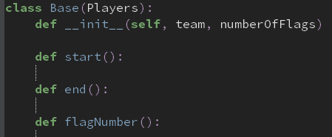

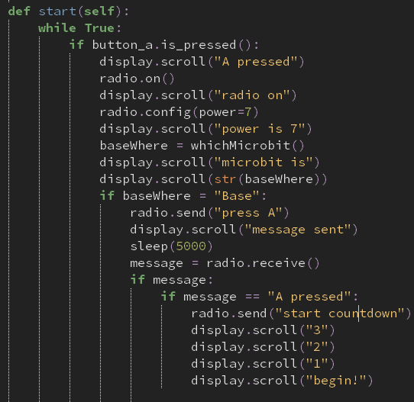
One altercation of the original CTF game is that base’s have to be on in order for the game to start. This is so all variables are initialised and flags can be stolen and placed to gain points. The start method in my Base class performs this action. When button a is pressed on the host basebit, the guest basebit receives a radio message that instructs the guest to press a in 5 seconds. If this is successfully performed, then a countdown will begin, and another function will be made in the future where all microbits have full functionality.

What am I testing | Input | Justification | Output | What to do
Start function | Radio messages from guest and host | For the countdown to begin | Syntax error at my second if statement | It must have a double equals sign as I am comparing two sets of data.    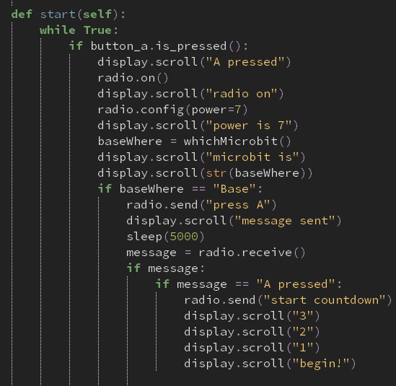
 |  |  | Name error at my whichMicrobit function | It uses a different function which I discarded for the sake of ease of testing. Instead, I will use return.
 |  |  | The happy face was displayed, but when I pressed button a, there was no countdown | Add a while loop inbetween the happy face line of code and the if statement in my guest bit.
 |  |  | When I press the A button when the happy face appears within the 5 second window, the countdown is initiated, however, the host waits for 5 seconds rather than doing the countdown simultaneously with the guest countdown. | Implement another while loop where it will check from 1 second to 5 seconds if a radio message is sent  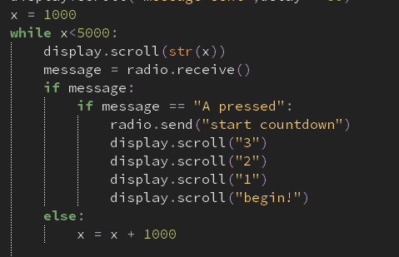
 |  |  | While loop is broken once a radio message is sent, however, it goes back to it when it shouldn’t | Set the while loop to True and when the message is sent to the host, the while loop should terminate.  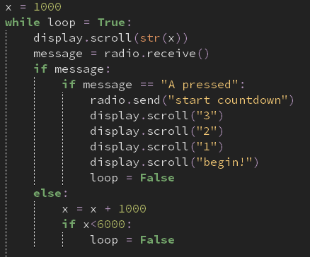
 |  |  | Syntax error at while loop = True | I recognised that because I’m using the comparative symbol equals, rather than the assigning symbol equals, I should use double equals, rather than a single one  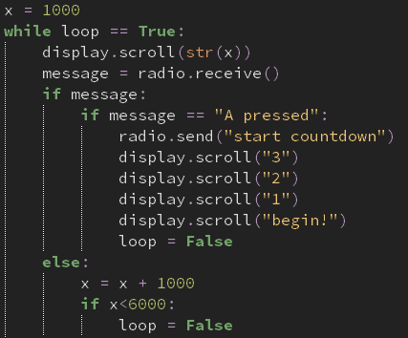
 |  |  | While loop ended too soon | Notice that my final comparative symbol should be > and not <  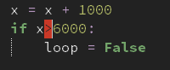
 |  |  | See video, it’s working. | Now, I have to remove the trace algorithm to hopefully make both microbits perform the countdown at the same time
 |  |  | No countdown. Empty screen. | I realised that I didn’t use the sleep function  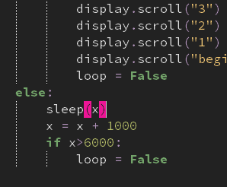
 |  |  | See video | NA

My start methods are working.

The end methods within my base class was pretty easy to program. This is because it followed the exact same formatting, only that a minor change had to be done for it to work. For example, the radio message that’s being sent, and the name of the method.
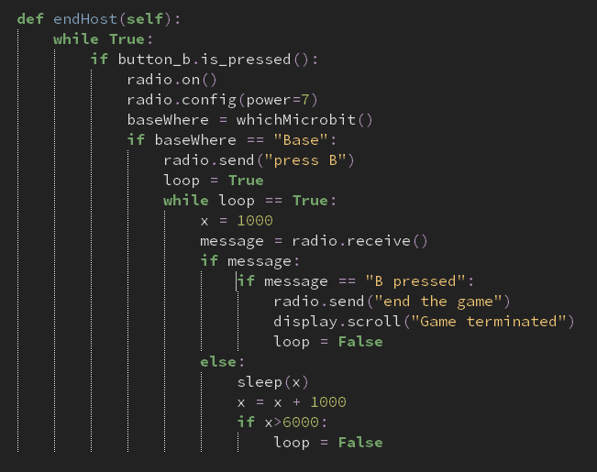
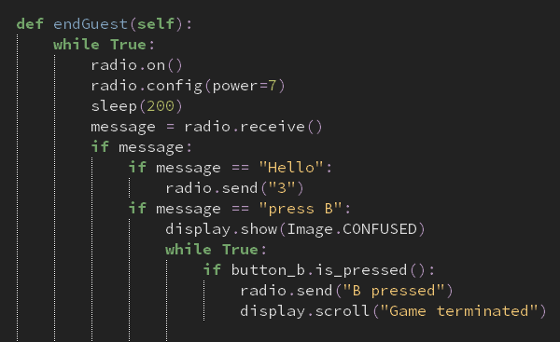
What am I testing | Input | Justification | Output | What has to be done?
End methods | Radio messages from guest and host | For the game to end | See video | NA

My end methods are both working.

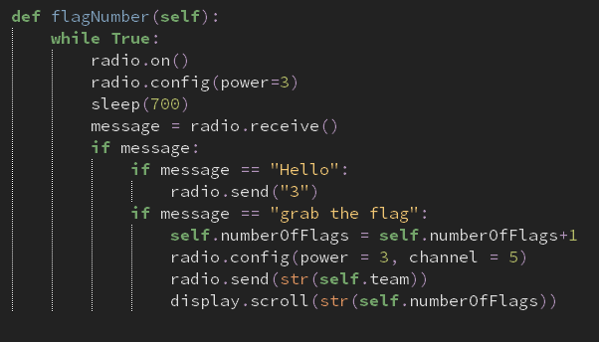
Flag number is a method also held in the base class. The purpose of this method is to increment the flags held within the base, essentially probably being the most important method within the base class. Simultaneously, for every flag that is collected, the flagNumber method allows the base to communicate to the masterbit and send the number of flags that it contains.
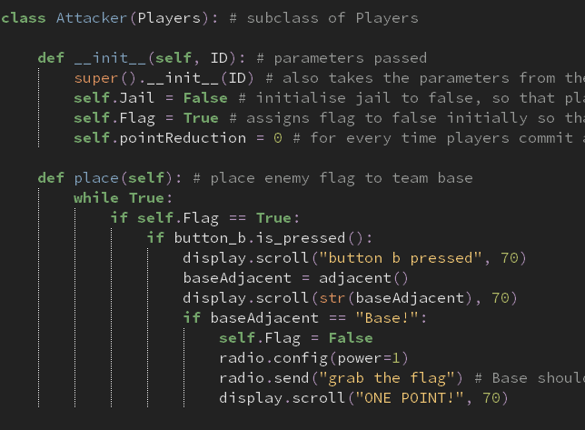
The reason why I am using this method from my Attack class is because in order for a flag to be placed in the base, it must be placed. The place method within my attack class is the way to perform this
What am I testing | Input | Just | Outcome | What’s needed to be done
FlagNumber method | Attacker | Places the flags in the base, which will then require the value of the number of flags to increment by one
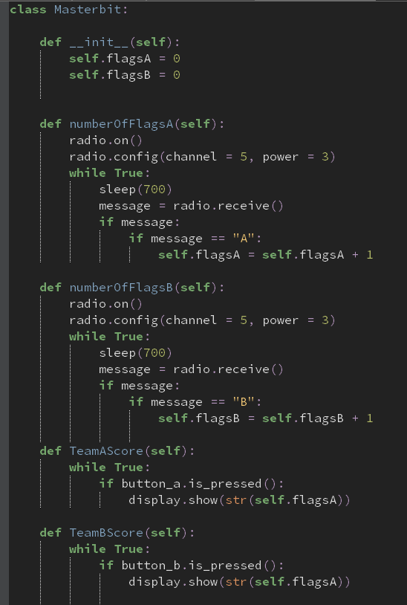
To keep track of scoring for both teams, the masterbit is kept well away from the in-game match, but not too far away so that radio signals aren’t reached to the microbit that behaves as the masterbit. A problem with the obsolete CTF game is that scoring may be difficult to keep note of because there could be players that may cheat and give more points to their team for example. A great way to come across this is to let a program handle the scoring to eliminate any kerfuffle between the two teams. It will infinitely loop through different methods within its own class, by having the bases feed through the number flags it currently holds to the masterbit, to act as storage to hold the number of flags for both teams. The way they can access this is by simply pressing button a or button b to display the score of either team a or team b respectively.

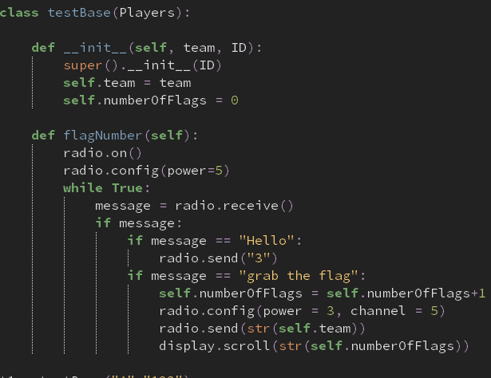

This is a test version of the base class which I have altered in such a way, for ease of testing, by allowing me to press a to increment the flags in the base by one, as well as feeding that value to the masterbit.
What I will be testing | Input | Justify | Output | What to do
NumberOfFlagsA | T1 = testbase(“A”,”123”) | Sends the current number of flags to the masterbit | See video, works! | NA
NumberOfFlagsB | T1 = testbase(“B”,”123”) | “ | “ | “
TeamBScore | Button b | When pressed, it displays the scores on team b that it has | Nothing on display | My display function I use is for team A, when it should really be for B.  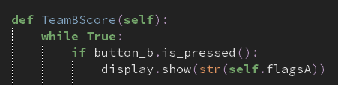  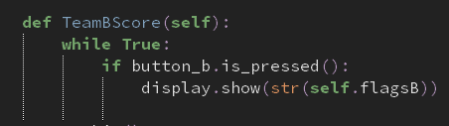
 |  |  | Nothing on screen | See if there’s something wrong with the display function by changing the argument given to an arbitrary word  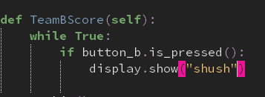
 |  |  | Nothing on screen | Recognise that it should be scrolling, rather than showing  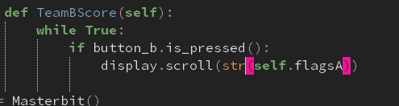
 |  |  | “ | Should be team b, NOT team A  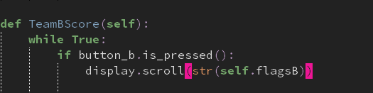
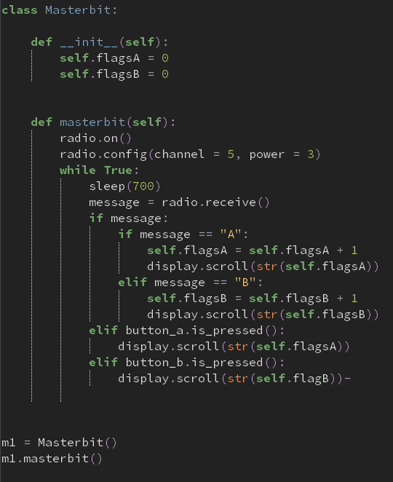
After several attempts, I noticed that this is actually the first time I’m using calling two separate methods within my testing, assuming it won’t mean no difference. However, when I create an instance of a class and then call two methods, which both contain infinite loops, it will stay in that block of code until it’s set to false, which it never does. Therefore, from hereon, essentially ALL of methods will have to be conjoined as one big method. The code below shows a developed solution of my masterbit class, which now works.

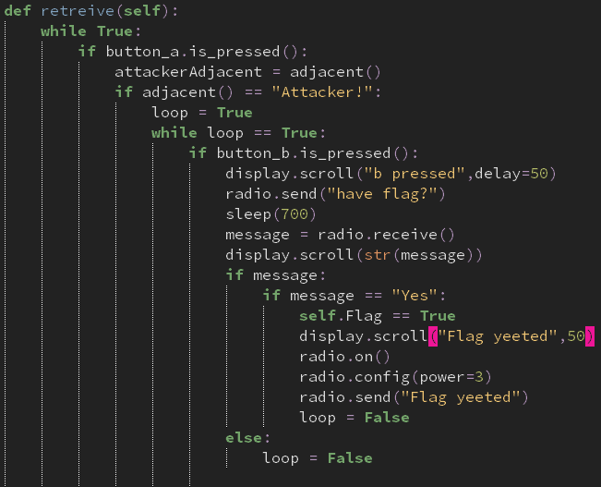
The purpose of the retrieve method is to take back team flags that are currently held by enemy attackers. This method belongs to the defender class, meaning that only defenders can commence this method when nearby to attackers and press B.

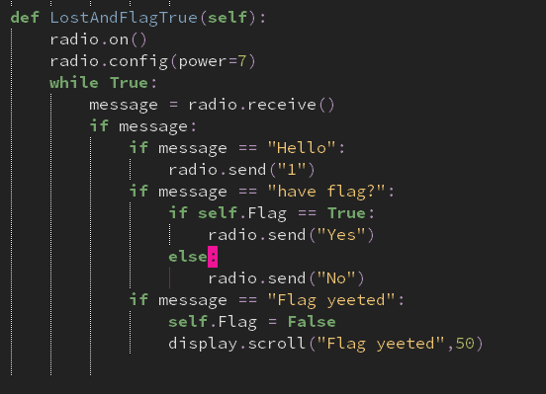
For testing purposes, I made a simplified version of the attack class, by using the methods required for the retrieve method to work. One being if there is an attacker adjacent to the defender, one if the attacker is holding a flag, and one to signify that the flag has been taken, or “yeeted”.

What’s being tested | Input | Just | Output | What has to be done?
Retrieve method | Attackbit | Radio signals allow the method know whether there’s an attacker holding a flag so it can be executed correctly | See video, works | NA

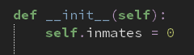In CTF, when a defending player catches an enemy attack that has no flag, they get sent to jail until their fellow attackers free them. The jailhouse class stores information of who’s in the jailhouse and who isn’t. The initialisation variable is inmates, set to zero. This is because at the beginning of the game, all players are on either side of the arena, and so no one would be in jail, until caught by the defenders, which will then increment the value of self.inmates by one. Jailhouse isn’t a subclass of Players because it doesn’t require the IDs of players as an initialisation variable.
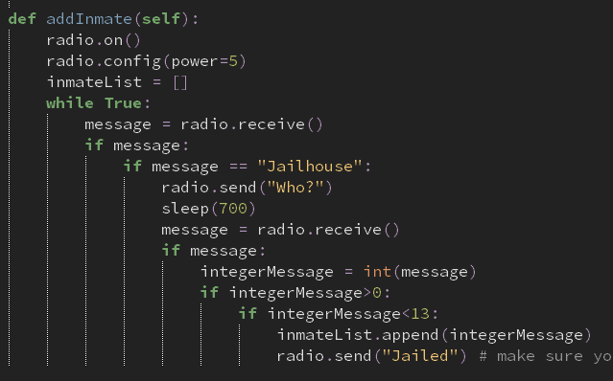
When a defender does successfully catch an attacker, it has to send that attacker to the jailhouse. The jailhouse receives radio signals to know that there’s a new inmate and what their ID is. This actually hasn’t been done in the defender class. However, majority of the capture method has been implemented and all that has to be done is to send a couple of messages to the jailhouse.
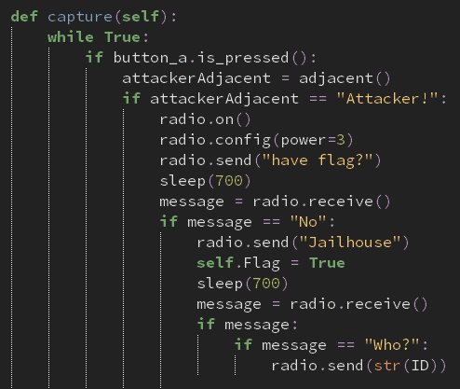
This is the developed version of my capture method within my defence class. What I have added is from radio.send(“Jailhouse”) onwards.
What am I testing | Input | Just | Outcome | What do you have to do
Capture | Attacker presence and no flag | So attacker can get sent to jail | Nothing on defender screen | Change the boolean value of self.Flag to False  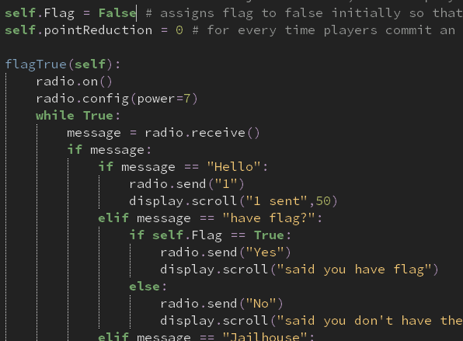
After plenty of attempts, I decided to rewrite my while loop and I ended up with the correct solution.
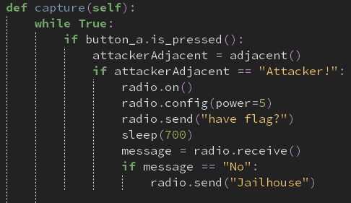
I now have to update it so that it can establish a connection with the jailhouse.
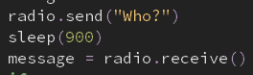
What this block of code does is ask for the ID of the attacker that has been caught. In a sense, indirect communication is made, as the defender then has to ask the attacker for their ID, which is then sent back to the defender, which is then sent back to the Jailhouse microbit. The defender has to switch channels for this to happen so that there aren’t any communication errors between two microbits. The two code screenshots below show the defender asking for the ID and the attacker giving it to the defender respectively.
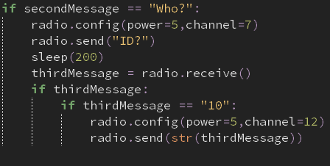
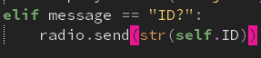
For testing, I have changed the final line of the addInmate method so that it displays “jail” when the message has been sent from the defender microbit
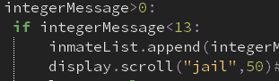
What’s being tested | Input | Just | Out | What next
Communication between jail and defender | Defender | Sends the ID | Line 58 Value Error | Turn on the radio  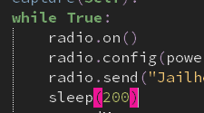  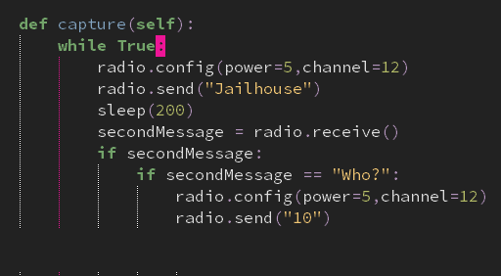
 |  |  | Line 50 value error after “jail displayed” | End the loop so that it doesn’t take “None” as a message. This is done by assigning the while loop to loop = True and until that’s false, it cycles through that loop.  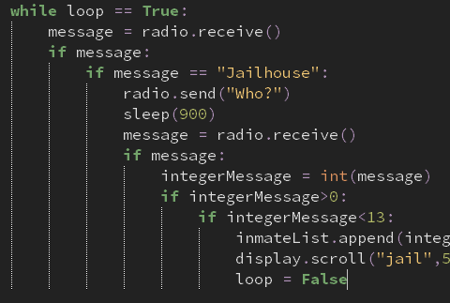
 |  |  | See video, working | NA
Defender and Attacker communication | Attacker | To see if ID is sent to defender | See video, works | NA
Defender and Jail communication | Defender

As both sides of communication are working, there is no need to edit anything.
Therefore, my jailhouse addInmate method is working.
Therefore, my jailhouse addInmate method is working
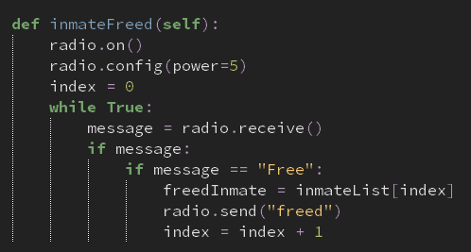
When an attacker attempts to free their teammate from jail, the jail will point to the person that was in jail for the longest, by using the inmateList and seeing who is first in the queue. This is different to the original CTF game because attackers can decide who they want to free. This may seem as a disadvantage as attackers may want to choose the better player rather than being a likelihood that they might be chosen, depending on whether they are first in queue. However, this could be countered as attackers would now have to be strategic about their game plan; if there is a player, say A, that is stuck in jail, and then player B is stuck in jail. If player B is the relatively better player than A, then they will have to wait to be freed until player A gets freed from jail, so that player B is the next inmate that will be freed.
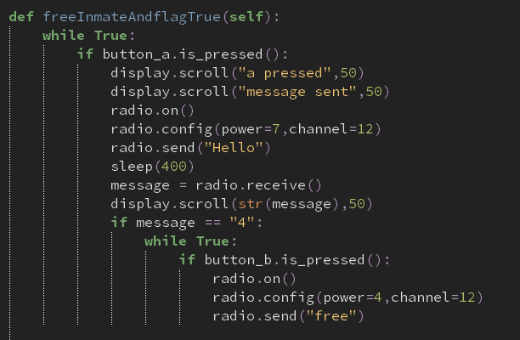
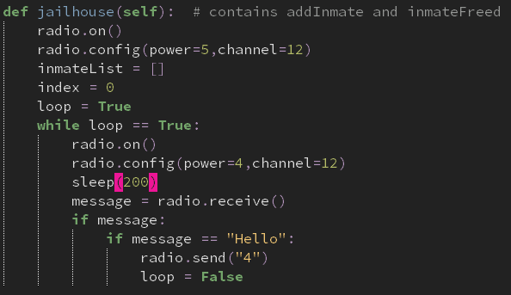
What I will be testing before any of this works is If there is a communication established between the attacker attempting to free their ally from jail and the jailhouse. The attacker will see if the jailhouse is near them. If it is, then the attacker will press a to take the inmate first held in the queue data structure. The screenshots below show the radio communications between the jail and attacker respectively. For testing purposes, only when button a is pressed on the attacker bit is when the program will execute

What’s being tested | Input | Just | Out | What next
Attacker and Jail communication | Jail | Sends back “4” when the attacker is close to the jailhouse so the player will know when to press A as it will be displayed on their microMap | See video, works | NA

Back to the main method I’m testing, the way that this will be done is by first having to put a player in jail, and this message will be sent from the jail to the attacker that’s being sent to jail. The first screenshot below shows this. After this, I would have to free them from jail with the help of another player. The second screenshot shows this. The list will be tested later on, as for now, all I am testing is if an inmate is successfully freed when the attacker presses A at a close distance.
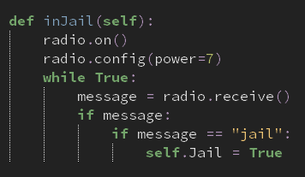
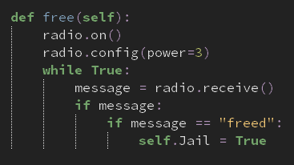

What is being tested | Input | Just | Output | What next
Is player freed from jail | Attacker rescuing player | To free the player from jail | “None” displayed on attack microbit assuming that there was no message sent to the jail. | Make it so that when a player is sent to jail, they’re sent to jail for the rest of the game and cannot be freed.

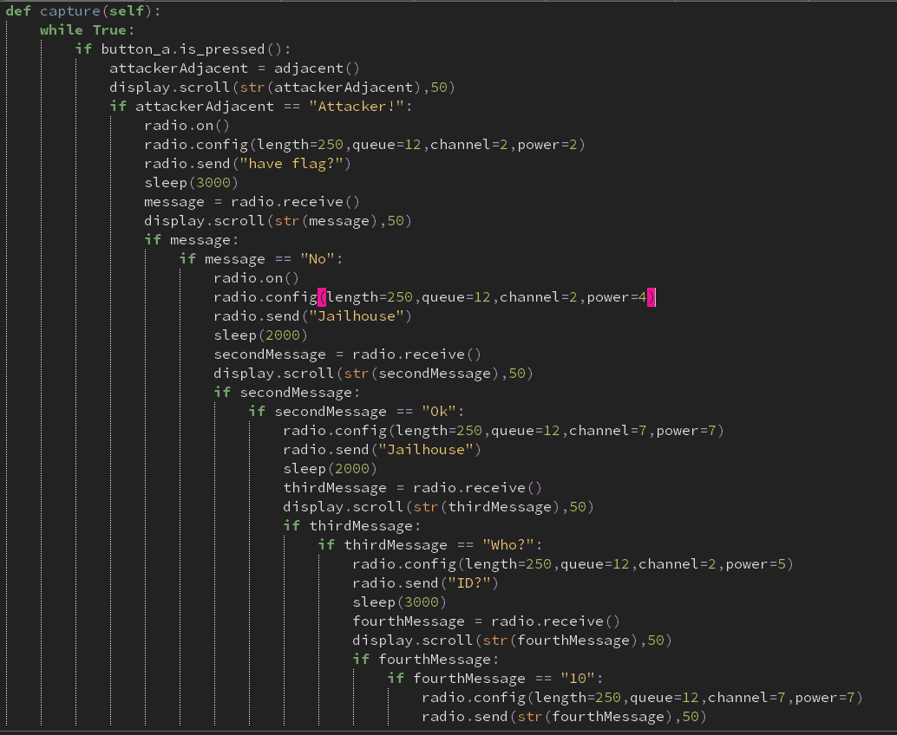

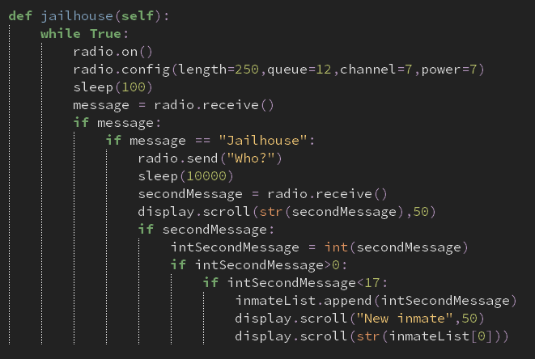

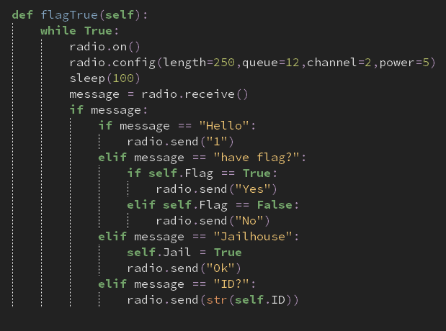

What am I testing | Input | Just | Out | Next steps
The communication between my jail, defender and attacker/inmate | Button A  Attacker ID  “Questions” sent from the jailhouse to the defender and/or from the defender to the attacker  “Answers” sent from the attacker indirectly to the jailhouse using the defender as a messenger | To successfully send the attacker to the jailhouse | Line 71, my radio send uses two arguments when only one is supposed to be used. This is in my defender class | Remove the second argument, 50, from the radio.send function  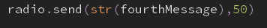  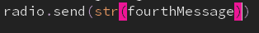
 |  |  | Line 47 in my jailhouse class, inmateList isn’t defined | Would have to be defined within my __init__ method as it is required outside and inside my jailhouse method  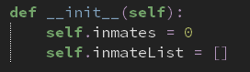
 |  |  | Line 49 has a name error | I have mistakenly tried to scroll inmateList instead of self.inmateList
 |  |  | See video, works | NA

I have developed my code so that the number of inmates is incremented by one every time the defenders successfully catch an attacker. I have further developed my code my scrolling the ID of the new inmate that has arrived, rather than just for testing purposes of just scrolling the first attacker.
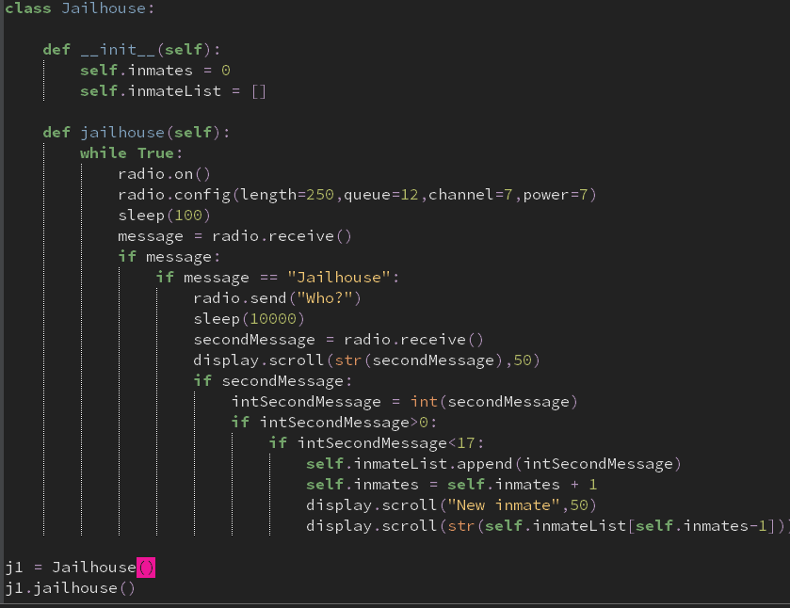
The flagTrue method in my attacker class is now fully working.
I tried to establish a method that allows my attacker to free other attackers from jail. However, there was no correct output after several hours of trying. So to make life easier for me, I have decided to tweak the criteria of my project so that instead of attackers being freed from jail, they have to stay in jail for the rest of the game. This is a massive alter for my game as freeing inmates is such a great way for them to have a second chance with a price to pay. However, it could be argued that this can improve the strategic play required in the game.
I tried implementing my own array of radio communications so that I can plot all the possible combinations for radio channels between two microbits that can work by using the x or y coordinate plane first. However, the program hadn’t even executed so far so that it could even be used.
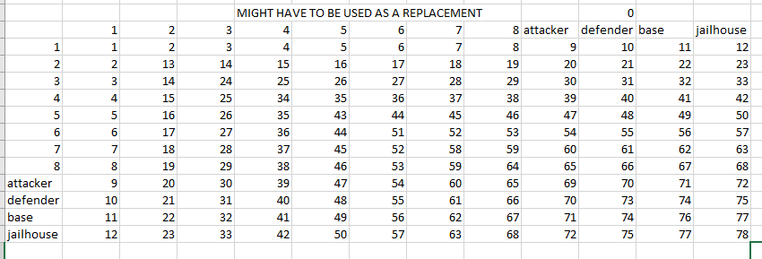

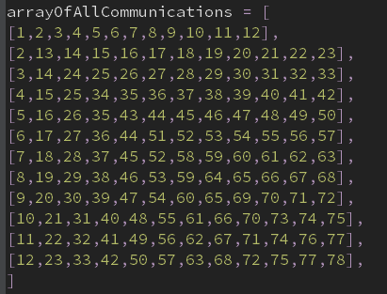

I also tried to alter my code for the sake of the jailhouse having to switch between two channels between one while loop. However, although my python syntax had been going accordingly, the logical syntax had blocked me from enabling this to happen, and essentially having to stop the idea of freeing inmates from jail.
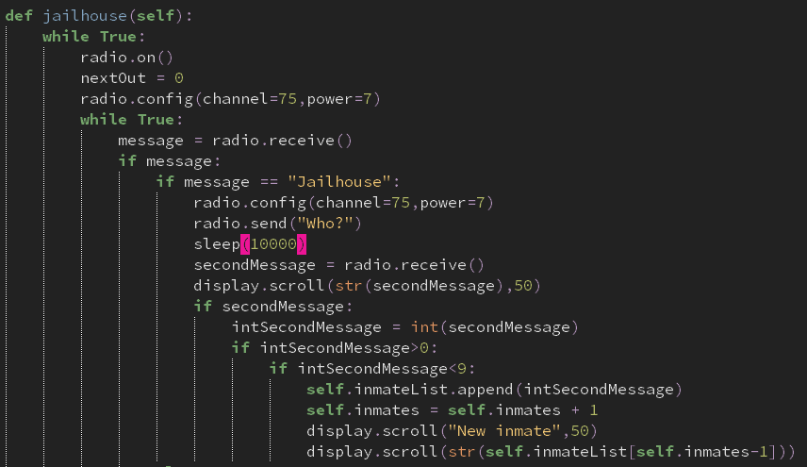

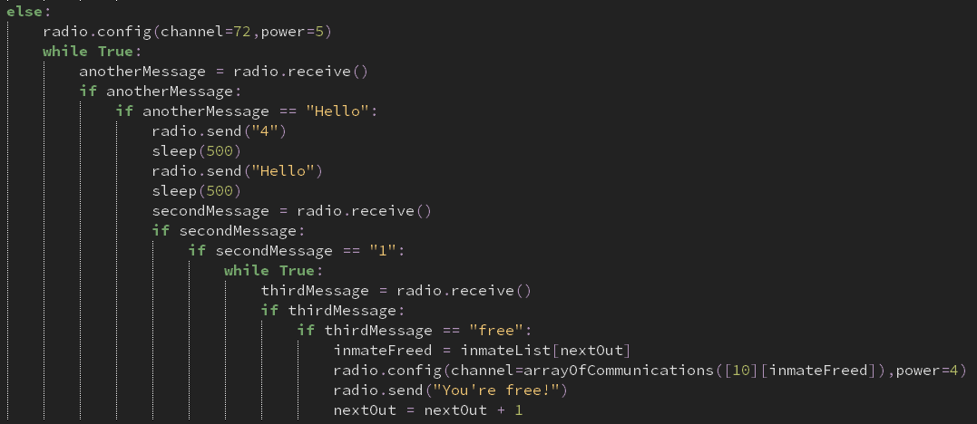

I didn’t have enough time to complete the rest of my coded solution due to such a shortage of time. So therefore, as of right now, my coded solution is at its highest level of prototyping before being sent off.

Evaluation
Requirement | Justification
Game involves two teams, A and B | This creates competition during the game along with a scoring system that builds tension as to who is to win first to 5 points
This has been met within the masterbit microbit that holds the masterbit class to take care of scoring from each base from each team. This was achieved through radio communications that the microbits have implemented on their hardware.
Requirement | Justification
A smooth communication system between microbits | Makes the game more easier to play rather than having to physically stop for radio communication to work properly.
This requirement has been met as the radio signals when testing had worked accordingly, although there were some hardware issues that would make the microbits fail to communicate and would, at a worst case scenario, mean that microbits having to be reset midgame.
Requirement | Justification
The intensity of the light is proportional to the distance needed for action to take place | So that players know when to correctly press the button without the need of having to enable the cool-down timer
This requirement was not met because I didn’t have enough time during my development to make this the case. However, a minimap was implemented in the microbit so that if the pixel is one pixel away from the base x-axis, it is safe for an action to be pressed without having a cooldown timer.
Requirement | Justification
Button a and b have different functionalities depending on the type of microbit | So that different microbits have different pros and cons to make things fair and to disable any biases towards one microbit.
This requirement has been met with attackers, defenders, bases and the masterbit having different functionalities to proceed to a certain action or to access information. This was made with the help of object-oriented programming as different classes had different methods.
Requirement | Justification
A scoring system has been implemented for the bases and the masterbit both in-game and post-game respectively | So that a continued rivalry is in full effect between the two teams and with the help of knowing who has more points, can mean having to continue playing the game to that one team is more superior than the other.
This requirement has been met as the base class involves having to increment the points for whenever the attacker placed a stolen flag into their base. Furthermore, my masterbit class had kept scores of both teams so that after the game ended, button a or b would correspond to the overall scores of team a or b respectively.
Requirement | Justification
Every class has been made so that communications between every microbit possible has been established | To ensure the game works at its full functionality so that all microbits can communicate with each other through radio.
This requirement has been met as each class has been carefully tested to ensure that the correct communication is made between two microbits.
Maintenance
There are many limitations within my game that I haven’t completed during my development. However, all my base modules have been made and I can work on these limitations based on what I have currently got going.
Maintenance and limitations
Not all the classes work around with each other
- There are some areas within each class that just don’t fit with each other.
Only available for one set of people
- My number of microbits is available for only a small set of people and cannot be generalised across other stakeholders.

